2020 Gerrardstown Good News
GPC Vision Statement: We are followers of Jesus who make disciples by loving unconditionally, sharing the good news, serving joyfully, praying expectantly, giving generously and believing God’s Word.
What Kind of News Do We Share?
By Pastor Karen
Already in this New Year there has been much in the way of news that has been shared. Some news is easy to categorize like the terrible news of the deaths of basketball star Kobe Bryant and his daughter and 7 other people in a helicopter crash. We mourn with these families. And there has been good news such as a FedEx driver ‘caught’ in the act of delivering a package and then shoveling the snow off a porch in the upper peninsula of Michigan. Or the Martinsburg 4H group raising money by jumping in a cold pool on a cold winter day to help further the efforts of 4H!
But what about the news stories that aren’t so easily categorized such as political, ecological or world event news which can cause some to cheer and others to be boo and hiss? What do we do with this kind of news? Sometimes we are quick to share with our own commentary or even an angry, sad face, heart or wow emoji under the caption. Sometimes we ignore it all.
What about the news we find in scripture? In Mark 1: 14-15 we read “After John was put in prison, Jesus went to Galilee, proclaiming the good news of God. ‘The time has come,’ he said. ‘The kingdom of God has come near. Repent and believe the good news!’”
This seems to be a bad news – good news kind of situation. Certainly John being in prison was not good news but Jesus doesn’t go about preaching that news. Instead he offered the people he met good news; telling them the kingdom of God had come near. Then Jesus added “Repent and believe the good news.” Why would we need to repent (which literally means turn around) to believe his good news?
In the vision statement of GPC, one way we make disciples is by sharing. What is it we are share as disciples? Our answer to this question is extremely important since we are Jesus’ ambassadors to our world. Our vision is that we make disciples by sharing the good news.
Jesus gave us an example of sharing good news even in the midst of his concerns for John. As he began his own ministry he brought all the goodness love, forgiveness, grace, power and the will of God with Him to all those he met. He called it the kingdom of God. But when Jesus ascended back to heaven, he didn’t take this kingdom with him. He left the kingdom in the hands of his disciples. He gave Peter and his disciples the ‘keys to the kingdom.’ These keys have been passed down through the centuries to believers in his church. What do these keys mean? They mean that we have been given access to God and faith to believe. We have this access today and are invited to believe that through the cross, Jesus has opened the way for us to continue to enjoy the glories and wonders, ‘the kingdom of God’ while we are still here on earth.
However, we may also need to repent of our unbelief. Jesus told those who didn’t believe but saw the wonders, that the kingdom had come near. This good news of Jesus isn’t any good to us unless we believe it to be true!
When we believe and begin to share the good news of the kingdom of God, we are sharing Jesus and seeking for God’s will to be done – like the Lord’s Prayer we pray. God’s good and wonderful will, is what Jesus said he did and what we are called to do. As he proclaimed the kingdom Jesus walked about healing, blessing, feeding, casting out demons, calling people to follow him, loving and forgiving people and dying on a cross so he could rise from his tomb three days later.
We are also called to share this same kingdom good news. Where will you share this good news today?
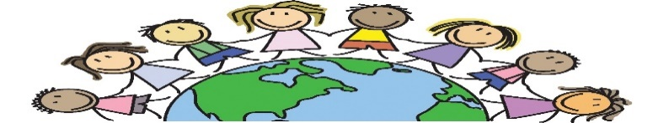
Share and Care Mission
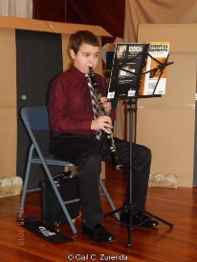
BE THE LIGHT!
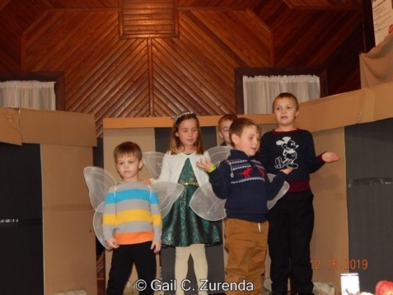
The Share and Care Mission team enjoyed participating in a Christmas play for the Joy Gift Dinner in December.
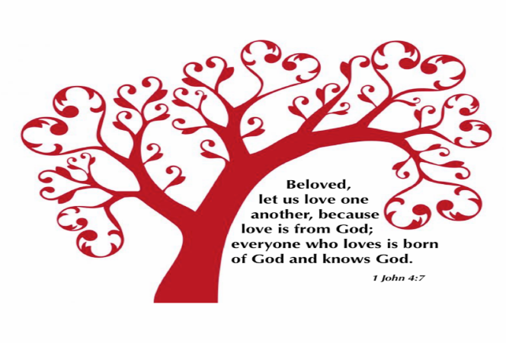
Come join the team as they plan Youth Sunday participation for March 1st and the Be the Light 5K Fun Run and Walk later this spring. The next meeting is Feb. 15th from 1-3pm in the Hall.
To contact Pastor Karen please call the church office 304-229-2316 or her cell 407-619-2821. Church email is gerrardstpc@gmail.com Facebook page is Gerrardstown Church Life Website is gerrardstownpc.com- our Service is posted on YouTube each Sunday!
All Are Welcome! Sunday Worship at 11am with Children’s Church at about 11:15am after the Children’s message.
Sunday Feb. 2 at 9:45am – Coffee and Conversations meets to study Isaiah For Everyone by John Goldingay in the Gathering Room behind the Sanctuary. At 12pm our Annual Congregational Meeting.
Wed. Feb 5 Mission Committee 6pm and Choir 7pm in the Sanctuary.
Friday Feb. 14 Happy Valentine’s Day!
Saturday Feb. 15 1-3pm Share and Care Mission Team meets in the Hall.
Monday February 17 Happy President’s Day!
Thursday Feb. 20 Session Meeting 6:30pm in the Hall
Wednesday Feb. 26 at 7pm Ash Wednesday Service at Tuscarora Presbyterian Church.
Tuesday February 25 at 4:30-6pm our Free Community Dinner in the Hall.
WE pray for: Terri Butts, Mary Campbell, Jane Wasson, Jodi VanMetre, Cindy Boyd Woods, Denise Churchman, Bob Frankenberry, Julie Shallis, Harriet Kopp, Carrie Brining, Janet Brown, Cindy Butts, Megan, Rev. Bruce Crabtree, Linda Hedges, Catherine Kates, Glen Sherrard, Dick LeDane, Raffi and Laila Kavaldjian, Dozer Cogar, Genevieve Pitzer, Bill and Janet Starr, Eileen Petersen, Janet Sherrard, Amelia Sturm, Samantha Oester, Jim and Kenda Butts, Linda Stillwell, Michael and Rachel Weller (Mission Co-workers), Nadia Ayoub (Mission Co-worker), those struggling with substance abuse and their families, those grieving and our community and government leaders, Christians brothers and sisters the world over.

