Welcome to the Good Friday Prayer Vigil…wherever you are.
Thank you for joining prayer with people in all different places as we each pray for an hour between 6am Friday to 6am Saturday.
Why Pray?: Jesus invited his disciples to pray on the night of his arrest.
Luke 22: 39-46 39 He came out and went, as was his custom, to the Mount of Olives; and the disciples followed him.
40 When he reached the place, he said to them, "Pray that you may not come into the time of trial."
41 Then he withdrew from them about a stone's throw, knelt down, and prayed, 42 "Father, if you are willing, remove this cup from me; yet, not my will but yours be done." 43 Then an angel from heaven appeared to him and gave him strength. 44 In his anguish he prayed more earnestly, and his sweat became like great drops of blood falling down on the ground. 45 When he got up from prayer, he came to the disciples and found them sleeping because of grief, 46 and he said to them, "Why are you sleeping? Get up and pray that you may not come into the time of trial."
(Lk. 22:39-46 NRS)
Mark 14:37-38 37 He came and found them sleeping; and he said to Peter, "Simon, are you asleep? Could you not keep awake one hour? 38 Keep awake and pray that you may not come into the time of trial; the spirit indeed is willing, but the flesh is weak." (Mk. 14:37-38 NRS)
And Jesus invited his disciples to pray at other times:
Matthew 5:43-45 43 "You have heard that it was said, 'You shall love your neighbor and hate your enemy.' 44 But I say to you, Love your enemies and pray for those who persecute you, 45 so that you may be children of your Father in heaven; for he makes his sun rise on the evil and on the good, and sends rain on the righteous and on the unrighteous (Matt. 5:43-45 NRS)
Jesus also offered suggestions on how to pray and how not to pray:
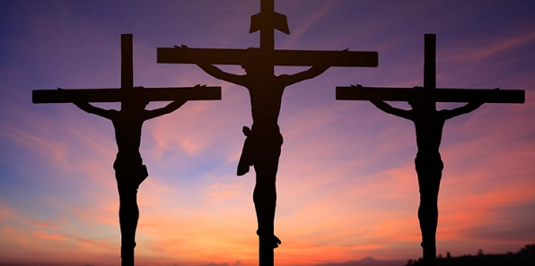
Matthew 6:5-15 5 "And whenever you pray, do not be like the hypocrites; for they love to stand and pray in the synagogues and at the street corners, so that they may be seen by others. Truly I tell you, they have received their reward. 6 But whenever you pray, go into your room and shut the door and pray to your Father who is in secret; and your Father who sees in secret will reward you. 7 "When you are praying, do not heap up empty phrases as the Gentiles do; for they think that they will be heard because of their many words. 8 Do not be like them, for your Father knows what you need before you ask him. 9 "Pray then in this way: Our Father in heaven, hallowed be your name. 10 Your kingdom come. Your will be done, on earth as it is in heaven. 11 Give us this day our daily bread. 12 And forgive us our debts, as we also have forgiven our debtors. 13 And do not bring us to the time of trial, but rescue us from the evil one. 14 For if you forgive others their trespasses, your heavenly Father will also forgive you; 15 but if you do not forgive others, neither will your Father forgive your trespasses. (Matt. 6:5-15 NRS)
Why Pray today?
Why would we pray on Good Friday? This is the day we are drawn to the cross where Jesus is crucified. All the disciples fled except for John and the women. There were many others who stood and watched so they could sneer and make hurtful remarks to Jesus. It was a lonely and painful day for our Lord and Savior. But without Good Friday there would be no Resurrection Sunday!
Let us prepare for the Resurrection by taking our place under the cross during this 24 hour vigil in prayer. In our hour of prayer time we remember the meal eaten together that is now what we call communion or the Lord’s Supper (Matt. 2:17ff). We remember Jesus washed the disciples feet (John 13). We remember Judas who betrayed Jesus with a kiss (Luke 22:47-48) . We remember that Jesus was arrested and put on trial with false charges (Luke 23). We remember how Peter denied knowing Jesus (John 18). We remember how he was made to carry his cross and when he couldn’t, they pulled Simon of Cyrene out of the crowd to carry it for him (Matt. 27) . We remember how he was led up the hill to Golgotha and crucified between two thieves (Matt. 27). We remember how he cried out “My God, my God why have you forsaken me?” the first line of Psalm 22 (Matt. 27). We remember how he offered life to the criminals who asked him to remember him when he came into his Kingdom (Luke 23:39). We remember how he said “It is finished and breathed his last.” (john 19) We remember how Joseph of Arimethea asked to take Jesus’ body and he wrapped him up and laid him in a new tomb (John 19).
We can come before God because Jesus went on the cross and when we trust in him he sends his Holy Spirit to help us especially when we pray (Ephesians 3:16, Rom. 8:26).
Let us pray prayers of:
Adoration and Praise for God our Father, the Son and Holy Spirit- there are so many praises we can offer God.
We glorify you our Father for your steadfast love that never ends, for your faithfulness and being our Creator God…Thank you for Jesus your Son who died on a cross taking all our sins, our pain and infirmities that by his wounds we are healed…Bless you Father for the Holy Spirit that Jesus promised to all who choose to follow him. Bless you for being greater than all the circumstances we face and for your forgiveness of the sin that seems too difficult to overcome. In your grace and goodness in Jesus we find life abundant, that is everlasting and we thank you for your Kingdom which is at hand. We bless you that you receive all the glory forever and ever Amen
For more prayers of adoration and praise visit:
https://myprayerinstitute.wordpress.com/2012/10/24/a-prayer-of-adoration-and-reverence-for-god-and-his-word/
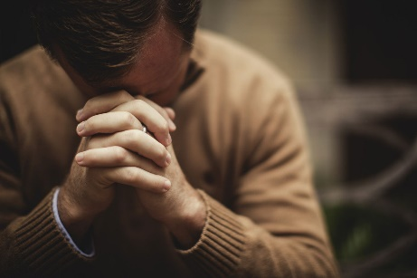
Confession and Repentance – we confess our sins and repent of them – the things we have done that we should not have and the things we didn’t do that we should have. Here is a Good Friday confession:

Good Friday Confession

We confess to You, our Lord and Savior,
that we have betrayed and denied You,
forgotten and doubted You.

When our faith is tested, we wonder where You are.

When we see injustice in the world, we often stand by,
we turn our backs, we ignore the cries of others.

We confess that again and again we deny You
and betray You with our silence
when we fail to proclaim Your Good News,
when we fail to live out Your teachings
and love our neighbor as ourselves.

Forgive us, O God, and help us to truly repent.

Help us to remember Your sacrifice,
Your love,
and to know Your forgiveness.

In the name of the One who lived,
who was crucified,
and who lives again,
Jesus the Messiah,
we pray.

Amen.
( Rev. Mindi Welton-Mitchell, from her website, Rev-o-lution)
Thanksgiving – Let us give thanks for all God’s promises, for all the answers to prayer, for God’s amazing love we experience in Jesus every day.
Here are some of the promises God has made: https://feelslikehomeblog.com/2018/03/standing-on-the-promises-of-god-70-biblical-promises-you-can-count-on/
Intercession – let us seek God’s help in areas of need with thanksgiving for in this way we are praying expectantly. Jesus has promised to intercede for us and that the Holy Spirit would intercede when words fail us. God has promised faithfully to supply all our needs. When we pray with thanksgiving we are believing God for that which we or others need. As the Apostle Paul wrote: 4 Rejoice in the Lord always; again I will say, Rejoice. 5 Let your gentleness be known to everyone. The Lord is near. 6 Do not worry about anything, but in everything by prayer and supplication with thanksgiving let your requests be made known to God. And the peace of God, which surpasses all understanding, will guard your hearts and your minds in Christ Jesus. (Phil. 4:4-7 NRS)
Some intercessory prayer topics listed below.
Prayer Concerns:
World
Environmental concerns
Political unrest
Peace
Immigrants
Health and well being
Leadership
United States
Federal, State and Local Governments
Leaders
Families
Drug and Alcohol Addiction
All those addicted and their families
Students and teachers all levels
Children – foster, immigrant, lost, abused, homeless
LGBQT persons and their families
Homeless people
Faith Communities – Muslim, Jewish, Other
Christian Churches and their ministries- all our sisters and brothers
Gerrardstown Presbyterian Church
Vision statement
Future
Finances
New members
GPC Ministries:
Coffee and Conversation
Children’s church
Make and Take
Community Dinner
Missions – local and world
Congregation
Pastor
New ministries…
Those God is drawing to GPC – especially those the congregation will be inviting

Other Links on prayer…
http://www.joyfulheart.com/maturity/prayer.htm
https://www.crcglobal.org/PDFs/The-P.R.A.I.S.E.-Pattern-for-Prayer.pdf

