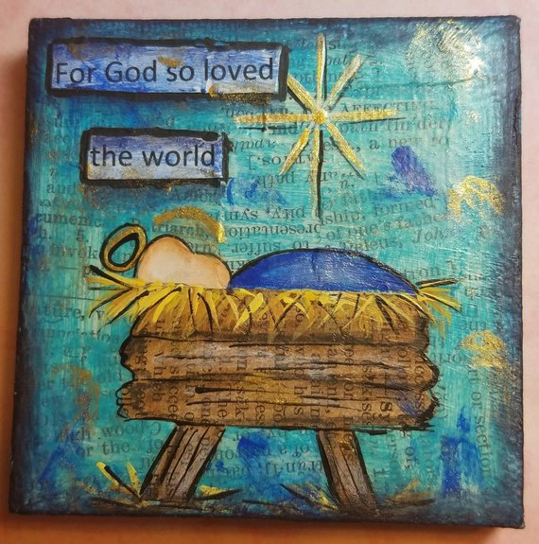
Christmas Make and Take Family Fun
Saturday Dec. 1st
3:30pm-5:30pm

Come celebrate the Christmas season of Jesus’ birth with a stocking craft, photo booth, the story of the first Christmas, carols, and a family meal.
Please bring socks to help us fill stockings for homeless children and adults

Gerrardstown Presbyterian Church Hall
372 Dominion Road, Gerrardstown, WV

