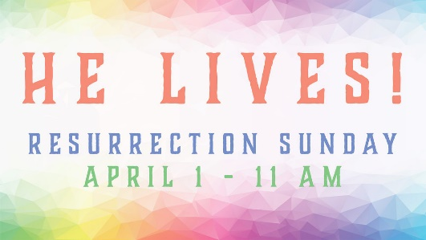
Gerrardstown Presbyterian Church Resurrection of the Lord
Easter Worship Service
April 1, 2018

~We Gather~
Prelude
Welcome and Announcements, Joys and Concerns of the Church
Please sign the red Friendship pad in the pew and pass along to others.
Easter Greetings –stand and greet each other as music plays please take your seats to sing Gathering Song
Gathering Song #231 Christ Has Risen While Earth Slumbers vs. 1
Prayer for the day
*Call to Worship
One: It’s true. It really happened!
All: Jesus Christ is risen!
One: Jesus Christ has risen indeed!
All Alleluia! Amen!
Hymn of Praise: #232 Jesus Christ Is Risen Today

~We Confess our Sin and Receive Pardon~
Call to Reconciliation: When we are full of doubts, lacking assurance and faith, when we feel we are full of darkness like a tomb; we need to confess to Jesus who is the master of overcoming tombs, doubts and darkness.
Prayer of Forgiveness: (Unison) Holy Savior, Light of the World and Hell bursting Christ, where else would we go but to you? We confess our minds are often clouded with darkness, shrouded with doubts or worry or pain. We sometimes feel bound up and held hostage. But in the bright light of your resurrection, we have courage to confess and once again invite you to break through bringing resurrection in us so we might live triumphantly in you… (silent prayer)

Assurance of Pardon: His cross burst our bonds and broke the hold of evil, illness and sin.
All: In Jesus Christ we are forgiven and set free. Hallelujah!
*Gloria Patri

~We Hear a Word from the Lord~
Special Music Easter Alleluia
Children’s Message
Hymn of Meditation #233 The Day of Resurrection
Prayer of Illumination
First Scripture Lesson: Is. 25:6-9
Leader: The Word of the Lord
People: Thanks be to God.
Sermon: In Step with Jesus: An Unlikely King
Second Scripture Lesson: Mark 16:1-8; Acts 10:34-43

~We Respond in Joyful Service~
Prayers of Intercession
Call to Offering
Offertory
*Doxology
*Prayer of Thanksgiving
*Apostle’s Creed

~We Go Forth to Serve~
*Closing Hymn: #238 Thine Is the Glory
*Charge and Benediction
*Benediction Response: Refrain: Thine is the glory, risen conquering Son; endless is the victory thou o’er death hast won.
Postlude

Adam Oester, Lay Leader
Beverly Hughes, Organist
Guest Organist, Maggie Jessop
Rev. Karen Greenawalt, Pastor

*You are invited to stand

Welcome to Gerrardstown Presbyterian Church. We are glad you are here! If you are a first time guest, please fill out the Red Friendship pads in the pew. We invite you to prayerfully consider GPC a place to call home. If you would like to become a member please talk to Pastor Karen.

Children are a vital part of our congregation. Each Sunday we offer Sunday school at 9:45am downstairs, a Children’s Message in worship and Children’s Church downstairs after the Children’s Message. Child care is also available in the nursery downstairs for all those 2 years and younger.
Upcoming Events- Mark your Calendars!
Pastor Karen will be on vacation April 19-24th
Sunday April 22 – Our Guest Preacher will be Rev. Roxanna Atwood
Tuesday April 24 – Community Dinner 4:30pm-6:30pm

RightNow Media is now available through GPC! To access this huge database of videos for children, families, marriages, Bible study. If we don’t have your email, please sign up at the Table in the Gathering Room.
Journey with Jesus to Jerusalem for Pentecost! We are continuing our walk until Pentecost. It’s not too late to sign up at the table in the Gathering room, pick up your packet and begin counting steps and miles as we add them together to walk the 5922 miles to Jerusalem by Pentecost.
Thank you all for bringing mission items for homeless people and pets! The Boys and Girls Club of Martinsburg invites us to help distribute the items collected to homeless on April 18th from 10am-2pm. Talk with Pastor Karen if you’d like to help.
HELP! If you know anyone in need of help with addiction or mental illness, WV has a 24 hour hotline 1-844-HELP4WV. The Suicide Prevention Lifeline number is 1-800-273-8255. If you know anyone who is having trouble paying a light bill, rent or needs mortgage help and other social services can be found by calling 211.
To Contact Pastor Karen please call the church office 304-229-2316 or her cell 407-619-2821. The church email is gerrardstpc@gmail.com , our webpage is http://gerrardstownpc.com/ . Like us on Facebook at Gerrardstown Presbyterian Church Life

