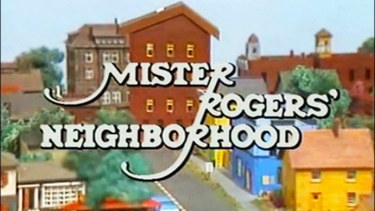
While We’re Waiting
Do you remember or did your children ever watch Mr. Rogers’ Neighborhood? If so, you may have heard his song “Let’s think of something to do while we’re waiting” http://www.dailymotion.com/video/x3659il
Mr. Rogers was one of the programs that our oldest girls watched when they were allowed to watch TV when they were young. I loved the quiet and comforting life in Mister Rogers’ Neighborhood. I also liked that Mr. Rogers did not shy away from the challenges that children face daily, because these very same things are what we face as adults. All we have to do is read the papers or watch the news to see that people are hurting, lonely, scared, alienated, sad, and don’t have a way to express or handle what they are experiencing. Maybe we didn’t all watch Mr. Rogers because maybe we didn’t realize how helpful it can be to watch a kind minister turned children’s TV show friend and neighbor.
The Christmas season is upon us whether we cherish it or would rather wish it away. It is here. In the church we call this time Advent- a time of waiting. ‘What are we waiting for?’ is a question I like to ask the children. But it is also a good one for us adults to ask ourselves. What are we waiting for? Waiting for the hubbub to die down? Waiting for our paycheck or retirement check so we can go shopping? Waiting for family to come or for family to leave?! Waiting for surgery or to finally be healthy again? Waiting for…?
Waiting is what Advent is all about….waiting for Jesus’ return. Maybe Mr. Rogers’ song ‘Let’s think of something to do while we’re waiting’ is appropriate for us to consider now or every day of the year. For all of our lives we are waiting for something or someone, especially if we believe Jesus will come again. But as Mr. Rogers says in the song:
Let's think of something to do while we're waiting
While we're waiting for something new to do.
Let's try to think up a song while we're waiting
That's liberating and will be true to you.

Let's think of something to do while we're waiting
While we're waiting 'til something's through.
You know it's really all right;
In fact, it's downright quite bright
To think of something to do
That's specific for you.
Let's think of something to do while we're waiting.

As people who claim Jesus as our Lord and Savior, we really do need to consider what we are doing while we wait during this Advent season and all year through. Maybe we need to first think about the fact that we are waiting! We may have gotten so caught up in everyday life and our worries that we have forgotten.

This month in worship at GPC we’ll be considering waiting and what we can do while we wait. We’ll light the traditional Advent candles of hope, peace, joy and love and then consider how these four could possibly be things we can be an important part of our waiting now and all year long.
I challenge us during this Advent Season, the beginning of the church year and the end of the secular calendar year, to ask ourselves ‘what will I do as I wait?’ Will I be involved in a liberating activity, a healing activity, a kind activity, a hopeful activity, a peaceful activity, and/or a loving activity? Something specific that is life-giving and maybe long overdue? Will I encourage others to join me in this activity?
I invite you to come and join in worship on the first three Sundays of December at 11am and on Dec. 24th, Christmas Eve to come to our only service – our family worship service- at 4pm, as there will be no 11am worship service that day. Then start your New Year off right by coming to worship on New Year’s Eve at 11am as we receive the Lord’s Supper. Maybe, just maybe if we consider hope, peace, joy and love this month, then we will realize Who goes ahead of us into 2018, even Jesus our Lord and Savior, lighting our way as He leads us to find what we will do while we wait.
You can also watch the sermon videos online at gerrardstownpc.com or check out GPC on Facebook at Gerrardstown Presbyterian Church Life

