Stuck in Time
Every so often I like to choose one of the classic novels as my pleasure reading. Sometimes I just want to challenge myself. So this fall I picked up Great Expectations by Charles Dickens. It has been a challenge indeed! So far, I’m only about a fifth of the way through, it seems to me this novel might have been better titled ‘Strange Happenings and Strange Characters’ because at this point that is what it seems to consist of.
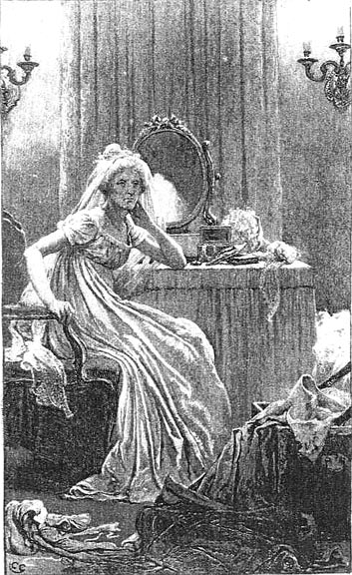
One of the stranger characters I met was Miss Haversham. She is a woman who is stuck in time. She resides in the moment when her fiancé jilted her on her wedding day. She remains trapped there – she in her white wedding dress now yellowed with age, gloves and shoes half on. Nothing’s changed – the table still set with the wedding cake that is crumbled into molding food for mice for over a decade. No light is allowed to come in the room. But what has changed is that Miss Haversham is no longer a vibrant human being living life. Instead Miss Haversham’s life consists of demanding that others provide a warped kind of life and entertainment so that she can vent her angry bitterness by belittling or being rude to others.
I feel very sorry for Miss Haversham and I don’t like her hurtful self-delusion. Do you know anyone who is stuck in time? Something happened in life that caused this person to stop living even though she or he was still alive? I have often wondered what my parents’ lives would have been like if their first child had not died at 3 days old. Their grief did not curtail the rest of their lives like Miss Haversham, but for my mother especially, it affected her view of herself and how she related to others. She was ever fearful that something she did might cause harm to another for the rest of their life. She never quite got over the guilt and sadness that somehow she was to blame for the death of their son, although there was no evidence to support this. It colored all our lives to an extent – much like the yellowing of the white wedding dress. It seems she never could really forgive herself.
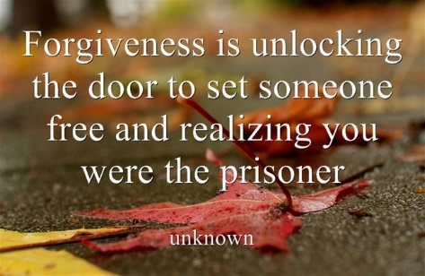
That life-giving action, forgiveness, seems to me to be the key to re-starting or restoration, but can be extremely difficult. Forgiveness does not mean we have to say the person, experience or situation was good, right, helpful or wanted. Forgiveness is simply saying we will no longer let whatever needs forgiving have a strangle hold over us any longer.
The Bible is chalk full of forgiveness stories beginning with Abraham talking to God about the people of Sodom and how many righteous people it would take before God would forgive the city’s sinfulness and spare its destruction or Joseph who finally forgives his brothers who intended to kill him but then sold him instead. David’s plea for God’s forgiveness for adultery and murder can be found in Psalm 51. Much of the Old Testament is a recounting of how the tribes of Israel and Judah were often in need of God’s forgiveness for turning away from God to worship other gods. Jesus continues this theme of forgiveness by telling his disciples they must forgive those who sin against us 77 times! Jesus talked about turning the other cheek and doing good to our enemies. Then Jesus demonstrated this in expressing forgiveness from the cross for those who put him there. Forgiveness is the life-restoring act we are offered from Jesus which we so desperately need not only for ourselves but to have at ready for all those who hurt us.
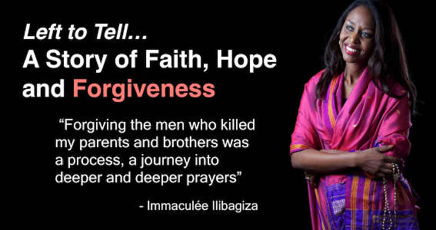
Miss Haversham, however seemed bent on being wounded for life and living in that bitterness for as she long as she could. Never moving past the awfully sad moment to see if there was more to life than this one relationship or if she might have had something to do with her fiancé leaving her ‘at the altar.’ Which is the greater sadness; the one devastating event or that this event was allowed to destroy the rest of someone’s life?
This summer at the Global Leadership Summit I had the opportunity to hear a talk by Immaculee Ilibagiza, who lost her family in the Rwandan holocaust. She has written a book about her experience called Let to Tell. In her talk she told about her inability to forgive those who had killed her family. She was spared but they were not. She and her family were Christians but she struggled in forgiving those who did this genocide. She realized the more she prayed, studied the Bible and tried to pray the Lord’s prayer that she could not forgive because she could not let go of her anger. She looked to God. She found through much prayer and much relinquishing, God could do in her what she could not. She learned that she was to pray for her enemies, so she would not be like them. She did not have to compete with evil. She could leave these people in God’s hands. Her job was to forgive. She closed her talk by saying “Remember there is always hope. God is almighty. He can help with anything. There is so much freedom in forgiveness.”
If you know someone who is stuck in time like Miss Haversham or Immaaculee, even if that someone is you, know that there is hope for life when we seek the forgiveness given to us through Jesus. As we let go of our anger and grieve with God’s help; we can receive the freeing grace of forgiveness for the people or the situation or the event that we’ve allowed to imprison us. Then we are free to enjoy life, laughter and love.

