Gerrardstown Good News
October 2017

Make and Take This Saturday Sep. 30th!
10am-11:30am

Teaching the Bible through Science Experiments
It’s going to get messy!
Gerrardstown Presbyterian Church
Preschool through 5th grade
Bring your kids for an interactive morning filled with Bible devotions that are begin taught through science experiments. The children will visit science/reading stations and create a memory book of their experiments to take home. Morning snacks will be provided for kids and adults. Nursery available. Please let Becca Sturm know if you would like to come so we have enough supplies for everyone. Email: beccasturm@hotmail.com or call the church @ 304-229-2316 Sign up tonight!

Did Jesus Ever Disagree? By Pastor Karen
This week as I was reading Facebook posts I ran across a discussion between a mother and son. What struck me was not that they disagreed, although I was somewhat surprised; but how they expressed love to each other even in the midst of their disagreement. This that made the discussion so, well, lovely! That is not a common sight on Facebook these days!

That started me thinking about Jesus. Did he ever disagree with anyone and if so, how did he handle it? As Christ followers we need to pay attention to how Jesus handled this part of life.

When Jesus taught his disciples about the Law as it applied to them in Matthew 5:21-25 we read: “”You have heard that it was said to those of ancient times, 'You shall not murder'; and 'whoever murders shall be liable to judgment.' But I say to you that if you are angry with a brother or sister, you will be liable to judgment; and if you insult a brother or sister, you will be liable to the council; and if you say, 'You fool,' you will be liable to the hell of fire. So when you are offering your gift at the altar, if you remember that your brother or sister has something against you, leave your gift there before the altar and go; first be reconciled to your brother or sister, and then come and offer your gift.””

Evidently Jesus expected even more from those who followed him than just don’t murder anyone! Jesus seemed to be saying be aware of your heart. He lifted up the need for reconciliation as being as important as the sacrifice. Jesus seems to suggest we need to first make the sacrifice of trying to reconcile with those who have something against us, then bring our physical sacrifices to God.

In other verses we find Jesus is the one in the midst of disagreement with some of the religious leaders: the scribes and Pharisees, the Sadducees and also the priests or chief priests. Over and over this cast of characters has lengthy conversations with Jesus, usually because they are on the opposite side of the fence from Jesus and sometimes each other.

Here’s what I have observed in scripture:
•Jesus and the religious leaders often begin a conversation with a question, rather than a flat out statement. This offers a way to have a conversation.
•There is one time Jesus derides the Scribes and Pharisees in a series of ‘Woes’ in Matthew 23. Jesus seems to assume the prophet’s role, like Isaiah, each woe describing a behavior or attitude that was not acceptable for religious leaders in their community. But outside of this very prophetic dressing down, Jesus regularly talks with the religious leaders on matters of the Law especially when they disagree on its interpretation in everyday life.
•There are two instances when Pharisees invite Jesus to dinner. (Lk. 7 and 14) And another time a Pharisee came to see Jesus at night to have a private conversation with him. Jesus socialized with everyone.
•Although the Pharisees and scribes are often described as conspiring against Jesus and wanting to arrest him, Jesus continued to live his life the same – healing, teaching, preaching and eating with sinners. Although sometimes he does continue this ministry away from the bigger towns.
•Jesus counseled his followers to beware and be careful about the Pharisees because they may try to trip them up. He suggested they be wise as serpents and innocent as doves (Matthew 10). This can be a challenge when emotions run high!
•Jesus, although deeply saddened and yes, sometimes angry and upset with the attitudes of their hearts, continued to try and instruct these leaders because Jesus knew they were still the ones in power and the people must answer to them.
•I also noticed Jesus continued to go to synagogue and Temple, even though it is obvious Jesus didn’t agree with much that the religious leaders were doing or saying. Their presence did not stop Jesus from attending services or celebrations there.
•Jesus paid the Temple tax even though his conversation with Peter would lead us to think that he might not need to; he did so anyway. (Matthew 17)
•Jesus asked his Father to forgive those who crucified him for they did not know what they were doing.

What does this say to us? If we are to be true to Jesus in our daily interactions with each other, it behooves us to ask more questions and listen closer. We also need to give each other the chance to explain. Even though we may disagree, let us, like Jesus try to keep the conversation going. Like Jesus, let us see that those who may seem to be our enemy are just people who have problems, hurts and hopes and may not really understand. And most of all Jesus said to his disciples, “I give you a new commandment, that you love one another. Just as I have loved you, you also should love one another. By this everyone will know that you are my disciples, if you have love for one another." (Jn. 13:34-35 NRS) Let us follow Jesus with love that produces joy, peace, patience, kindness, generosity, faithfulness, gentleness, and self-control (Gal. 5:22-23 NRS) – even with people with whom we may disagree.
A BIG thank you to all came to our blood drive- whether you volunteered, brought snacks, tried to give or did give blood! Nineteen pints of blood were collected!
Oct. 1 -World Communion Celebration Sunday at 11am and Fellowship Meal afterwards. Marie Keegin from Faith Community Coalition for the Homeless will join us and share about FCCH, what their mission is and how we might help.

Oct. 3 – GPC Music Team practice 7pm in the Sanctuary.

Oct. 5 –Come and Pray at 7pm -Anyone who needs prayer or wants to pray for a family or friend is welcome to come to this informal gathering in the Sanctuary.

Oct.7 Grace Weekley Memorial Service 10am with lunch following the service.

Oct. 19 –Come and Pray at 7pm

Oct. 28 Hayride and Marshmallow roast 3:30-5:30pm

Oct. 31 Halloween Community Dinner 4:30pm-6:30pm Come to eat and/or Trick or Treat!

Nov. 11 – Faith Community Coalition for the Homeless Keep the Faith 5K Color Run at Poor House Park. Registration starts at 10am Run starts at 11am…for more information go to FCCH website. https://faithcommunitycoalitionforhomeless.com/

Nov. 22 – Community Thanksgiving Meal 4:30pm-6:30pm (no community dinner Nov.28)

New Handicap Bathroom is completed!
With many stops and starts along the way, the new handicap bathroom is finally completed and awaits the final inspection. Many thanks to Tom Greenawalt for his oversight in this long construction process!
The Session met September 18th 2017 and several actions were taken. The Session approved the annual school supply collection for Gerrardstown Elementary, and a collection for the month of September for Presbyterian Disaster Assistance to help those affected by the recent hurricanes. Session approved reconfiguring the space behind the sanctuary, removal of the display cabinet and re-naming the space behind the sanctuary, which now houses the handicap bathroom. Session is inviting the congregation to submit names for their consideration. Session approved rescheduling the EPMC Music Fest Sunday to Oct. 15 at 4pm at GPC. Session approved the donations for the Oct. 31 Community Dinner be given to the street light fund in Gerrardstown. Session voted to not offer Trail Life or American Heritage youth groups at our church due to restrictive language on who was allowed to join. Session voted to hold a Congregational meeting Oct. 22 at 11am to hear the report of the Nominating Committee, receive nominations from the floor and vote on nominations of elders. Session voted to elect Glen Sherrard as commissioner to the November Presbytery meeting at 3rd Church Staunton.
Property Committee is working on requests for railings next to steps in basement and the need to fix the kitchen sink in the Hall.
Cemetery Committee reported that is has become necessary to replace the 2006 Model X300 John Deere riding mower. Being over 11 years old, with 1,154 hours of service, it needed over 1000.00 in repairs. The repair costs exceeded the value of the mower. The best price to replace the mower was 3300.00 plus the Mulch on Demand conversion, which is necessary to keep the grass from being side discharged onto the tombstones. Presently, donations from the Paul Boyd Memorial fund total $1135.00. These have been deposited and Thank You notes sent for each contribution. This alone will cover 1/3 of the cost of the replacement mower. The committee believes Paul would be happy to see the money put to good use, and to have it spent locally for his favorite color, John Deere Green.
Pastor Karen reported that her liaison work at Bunker Hill is nearing a close as they have extended a contract to a candidate as Temporary Supply pastor, who, if the way be clear, will begin in November. Next Session Meeting is October 16, 2017 at 2:30pm.
Active Session Members: Harriet Kopp, Clerk, Glenn Sherrard and Stephen Zurenda.
Mission Made Possible by You!

Rescue Mission is in need of soap, deodorant, shampoo. Please bring and place in the barrel in the Lecture Room.

World Food Day is October 16th.
http://www.fao.org/world-food-day/2016/home/en/
This date was set by the Food and Agricultural Organization of the United Nations. Achieving food security for all is at the heart of FAO's efforts – to make sure people have regular access to enough high-quality food to lead active, healthy lives.
At GPC we address hunger issues by joining with the Mt. Pleasant UMC to provide the free Community Meal, we take a quiet offering that goes to CCAP Loaves and Fishes who provide help for those who are hungry or have other needs, we support the Backpack ministry in the schools and food and supplies for the Rescue Mission in Martinsburg.
What else can we do to help people have regular access to high quality food in their lives?

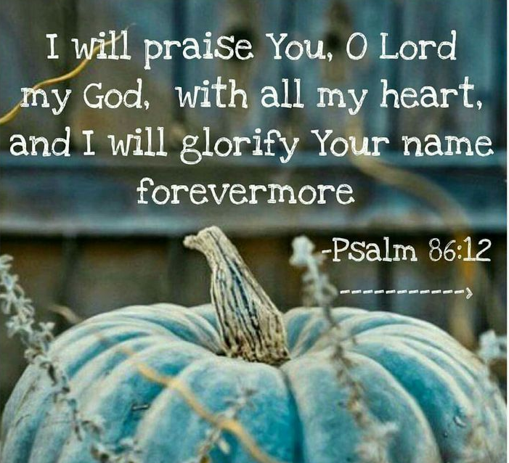

Like us on Facebook at Gerrardstown Presbyterian Church Life Check out our webpage at gerrardstownpc.com

