When God Calls Your Name
I grew up as one of four girls. When my mother would start to call one of us, she would often go through all the names until she came to whichever one of us she meant to call. Fast forward to when I became the parent of four children. I found myself doing the same thing! And if truth be told, sometimes the dogs’ names ended up in the list before I would get the correct child’s name called out!
The story in Genesis 46 is of a child of God who isn’t young anymore but we find God is still calling his name. And since God is our heavenly parent, God, it seems, does not go through the other children’s names to get to Jacob! However I have wondered with 12 sons, did Jacob ever go through all those children’s names to call that one child.
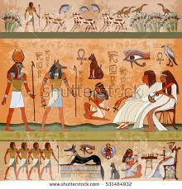
In this part of Jacob’s life, there are only eleven sons that he knows for sure are alive. Due to a terrible drought ten of the eleven sons had journeyed to Egypt and back to buy grain. On their last trip, they hurried back to tell Jacob the good news, Joseph, his son by Rachel, was alive! He was not only alive but he was second only to Pharaoh in the land of Egypt!
When Jacob’s sons told him Joseph was alive in Egypt and that there was food and grazing lands for them there –Jacob was in disbelief! And yet there stood the wagons Joseph had sent back to carry them all to Egypt. They told him, Joseph said to come- come and live in Egypt. Finally Jacob relents and agrees to go with his sons. On the way he stops at Beersheba and offers sacrifices to God, the God of his father Isaac. And there in a vision at night God speaks to Jacob, “Jacob, Jacob” and he said, “Here I am.” Then God said “I am God, the God of your father; do not be afraid to go down to Egypt, for I will make of you a great nation there. I myself will go down with you to Egypt and I will also bring you up again; and Joseph’s own hand will close your eyes.” (Gen. 46:1-4)
Such beautiful words to hear as Jacob was in the process of moving everything he owned to a foreign land. Joseph would never see Canaan again alive. He would die in Egypt after his reunion with the Joseph, his first son from Rachel, the wife he’d always loved. His twelve sons, the twelve tribes of Israel would flourish and become so powerful that later this would bring servitude to the people of Israel under a different Pharaoh.
There in the midst of a terrible drought in the land of milk and honey…God still brings blessings. Maybe not in the way Jacob thought they would come. I’m sure it never occurred to him that Joseph was alive and had become powerful in the government of the Pharaoh of Egypt and would eventually rescue his entire family and provide them a home. Jacob, the conniver and schemer from birth, seemed to be without any scheme or plan after losing Joseph. Even after the good news about Joseph, he seems be overwhelmed by this move and the nearly impossible idea of his son, who was dead, was now alive. When Joseph takes him to Pharaoh, Pharaoh asks Jacob his age. Jacob replies, “The years of my earthly sojourn have been one hundred and thirty; few and hard have been the years of my life. They don’t compare to the years of my ancestors during their long sojourn.”
Most of us would not think 130 years as a short span. We might think we have barely lived in comparison to Jacob. It was true, Jacob had worked hard for Laban and had many children by Leah and two by Rachel and many by their maids. He had been reunited with Esau, his twin brother, who he had been estranged for long years because he’d bartered for Esau’s birth rite with some stew and stole Esau’s first born blessings by pretending to be Esau to Isaac. Jacob had prospered but at what cost? For the band of brothers born to Leah had ganged up on Joseph, the one Jacob favored and had sold him to a band of Ishmaelites and told their father he’d been killed. Difficulty and heart ache had accompanied his prosperity.
What have the years of our lives produced? Are our lives similar to Jacob? Do we have competing forces in our own families? Are there troubles we never would have imagined? Have there been years of ‘drought’? Do we look back with some regrets or feelings that the years of our life have been ‘few and hard’? Or are we able to see through the heart ache and the pain, through the disappointments and despair? Are we able to dimly see God’s hand bringing us through it all? Certainly Jacob’s offer of the sacrifices to God that day in Beersheba, as he left everything he’d ever known for this final move, brought him comfort. At some level he knew God was in the midst of yet another change in his life. And God responded by graciously coming to Jacob and letting him know that God had always been at work behind the scenes, and would never leave Jacob alone.
It’s hard to move from the place where you’ve spent nearly all your life – nearly 130 years – and go to an unknown land. Where would he stay? Who would take care of him? Rachel had died years before in child birth having Benjamin. And later he had buried Leah in the same grave with his father Isaac, his mother Rebekah and Rachel. Yes, there were all the children and grandchildren, but who would care for Jacob?
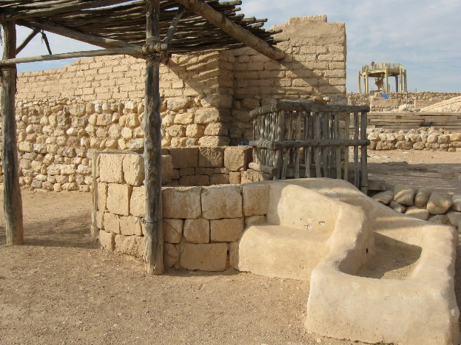
Jacob’s answer was also offered to him by God at Beersheba. God would go with him. Joseph would close his eyes and God would bring him up again. He would not be alone or buried in this foreign land, among foreign people who didn’t know or serve his God. Had God finally become Jacob’s God? A few verses later Jacob blessed Joseph’s children and said “The God before whom my ancestors Abraham and Isaac walked, the God who has been my shepherd all my life to this day, the angel who has redeemed me from all harm, bless the boys and in them let my name be perpetuated and the name of my ancestors Abraham and Isaac and let them grow into a multitude on the earth.” (Gen. 48:15-16)
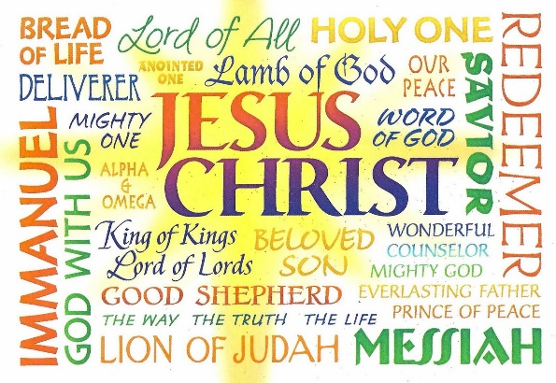
Jacob, who had once wrestled with God and had the courage to not let go without a blessing; was given a new name, Israel, for his persistence. It seems he was once again holding onto God with all his might as he moved toward the end of his life in Egypt. But the story does not end there. His children and grandchildren became a great nation and ultimately from his loins came the Lion of Judah, the Lamb of God, Jesus, the Messiah who would gather all the world to himself on the cross bringing life from drought of death and giving living water of eternal life to all who agree to leave their old lives and live in him.
We may not know what specific vision given to each us by God. However, if we, like Jacob, hold on to God with all our might, sacrificing our praise and thanksgiving to him through his Son Jesus, he calls to us through his Holy Spirit who goes with us, no matter our journey, till our lives end with him. To God be the glory!

