God’s Will or My Will? Are we doing God’s will or trying to create God’s will in our own image?
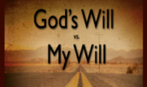
This could have been the plot for a made-for-TV movie, it was so full of drama, suspense and heartbreak. A God-promised baby isn’t forthcoming as soon as the older mother thought so she improvises by substituting her slave girl for herself with her husband. When the slave girl becomes pregnant from this twisted and warped version of pro-creation, her mistress is outraged at how contemptuous the slave girl is being towards her! She, whose idea this was, wants this girl gone, baby and all! What had started out as a way to create God’s will in her own image had produced only heart ache and hurt from an action that today we would call sex trafficking.
You may know the story I just described. It is the famous story of Abram and Sarai and Hagar the slave girl who bears a son to Abram. (Genesis 16). This faithless plot to fix God’s unfulfilled promise of a descendant for Abram and Sarai only served to create hardship and resentment. How often do we, like Sarai and Abram, believe God for so little? Instead of waiting expectantly, we feel we must try to help things along to make the promise happen. As if God needed any of our ‘help’ to work in our lives. Oh how often we too are people of little faith! Jesus often used this description for his own disciples and I’m afraid we are not much different sometimes.
In the brokenness of human fixing, however, God is merciful and gracious to all involved. When Hagar runs away because Sarai treated her harshly, God shared with her the plans God had for Hagar, including the new babies’ name, Ishmael, which means ‘God hears’. Ishmael it seems will be quite a young man with ‘his hand against everyone and everyone’s hand against him.’ His turbulent life won’t be easy but God promises later ‘he will be father of twelve princes and a great nation.’(Gen. 17:20).
God who allows us to make our own decisions – even ones that aren’t for the best – still offers us grace in midst of our human-made messes. For God’s wonderful and generous grace is more bounteous than our boundless need for it!
Hagar and Ishmael survive even after Sarah has Abraham send them away for good after Isaac is born. Is it any wonder there are hard feelings between Ishmael’s descendants, the Arab nations and Israelites? As the Psalmist so aptly wrote, it is a wonder that God takes any notice of us for all the havoc we can produce! The wonder of this story may encourage us to give thanks to God in at least three ways.
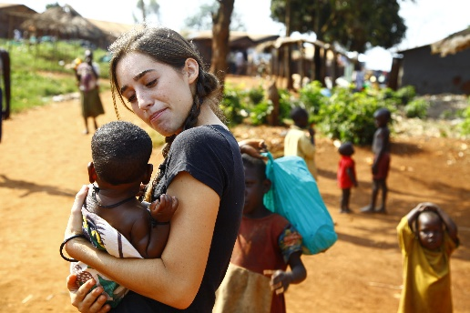
We can be thankful that God heard and still hears the cries of rejected mothers and children – even though they may have been thrown aside. God has promises and blessings for each of them because God does hear and love the ones on the margins, the ones no else seems to love. We only have to look at Jesus to see how he loved and cared for all those who were considered of little worth, such as the outcasts or unclean.
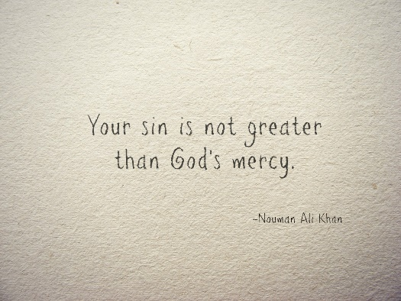
We can thank God for God’s great mercy and forgiveness, as God gives new names to those who have hurt or despised others – offering the newly named Sarah and Abraham a second chance to be in covenant with God and giving them the promised child, Isaac, who was born out of laughter. We too may need a second chance. We find that this is exactly what Jesus offered, even to those who hurt and killed him on the cross. He interceded for their and our forgiveness with God and offers us a new chance in life as we come to know him as Savior and Friend.
We can be thankful even though we too may laugh like Abraham at outrageous and amazing miracles that are worked by our God. May our laughter be full of awe and wonder in order that we may also receive God’s love and miracles in Jesus, may we come to see the ones on the margins who God loves and yearns to care for through us, and may we realize we also can forgive those who have hurt or despised us, for Jesus has forgiven us. For this is God’s will being done.

