Drawn Into the Story
Don’t you love a good story? There is something about a story that takes us out of ourselves and into someone’s life, their home, their problems, their fears, hopes and dreams. Before you know it, we are immersed in their story as we find how it connects to ours.
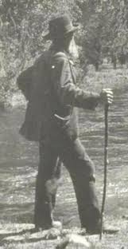
Stories are what I take to Gerrardstown Elementary each week to entice my first grade class to listen and imagine as we enter into the world of books. In the New Year, I began a chapter book, although it did have a few pictures to help us bridge the picture book stage – more pictures and less words to the chapter book stage – less pictures and more words. I chose a man who liked to travel especially in the wilds of America in the late 1800’s. John Muir had some great adventures and we traveled across the country with him as we entered his story.
Stories are my favorite part of the Bible too. This past week the book of Ruth has been my reading. I was carried back to Moab with Naomi as she finds herself a widow and mourning the loss of her two sons. Naomi reaches the lowest ebb in life – sure that God has left her and in her desolation she tries to send everyone else away too. After many tears one of her daughter-in-laws, Orpah leaves to return to her family but Ruth, her other daughter-in-law refuses. She will not leave no matter how angry or sad Naomi may be. She won’t leave because Naomi has become her family and her faith story is bound up with her new family. Ruth is God’s blessing to Naomi that she doesn’t know is hers.
Stories are the stuff of which our lives are made. We are nothing without our stories. What is the story of your life? Where have you been and where are you going? I am amazed as I look back on the story of my own life. For it seems in looking back we are able to peer around and see, like Naomi eventually does, that we have not been deserted by God, though we may have felt deserted. We have not been left alone. Who is your Ruth?
God, you see, is a bit like Ruth, refusing to leave us even though sometimes we may feel like God isn’t there. Jesus showed us God’s promise to never forsake us for God is Emmanuel, God with us in our story!
When we realize the unseen Presence of God in our story, your story and my story begin to have another dimension. We begin to see there are possibilities that weren’t there when we felt we were alone in this story. We may even begin to see that the ending we had proposed is not nearly as good as what God offers us. When we join our story to God’s – great things can happen!
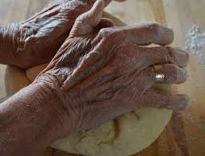
Jesus was the best story teller of all. He knew how to draw us in and share the measures of the Kingdom of God in ways we never dreamed possible. He knew that when we forgot ourselves as we are caught up in Jesus, we enter into the Kingdom and life. We begin to understand that the story of the Kingdom of God isn’t quite what we thought it would be. The story comes quietly, unseen. It comes by way of a woman’s hands kneading dough or a mustard seed slipped faithfully into some dirt with little fanfare. Hands that are held in prayer or words in prayer whispered with love and faith plant the Kingdom grace in places that are desperate, devastated and we see the story change and life is born.
This story of God’s grace shown to us in Jesus’ life on earth is a never ending story. Jesus still invites us to come along and share in the story of forgiveness, joy, and togetherness found in sharing the story of love with him. Then we can offer others to join their story to ours and find the story of the Kingdom of God blossoms more beautiful than ever before.

