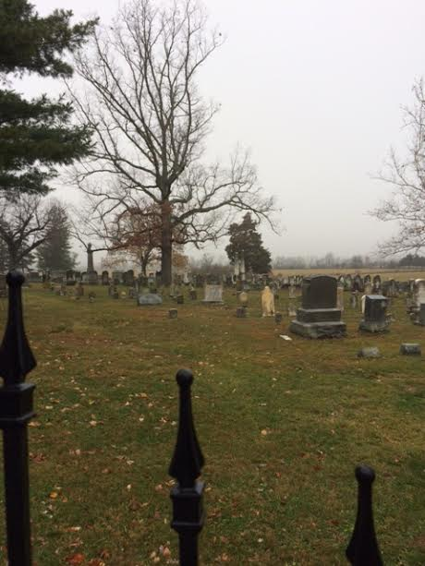
A Flood for Good
It’s raining today in Gerrardstown, the cloud cover is thick and it’s cold. The idea of a rainbow seems unlikely. The daily Bible lectionary I have been reading this week is centered in Genesis 6-9, the story of Noah, the Ark and the flood. It seems strange to me that Noah’s ark is often celebrated in children’s toy stores, clothing and songs. It wasn’t a very happy event - more a terrible tragedy with a somewhat happy ending in the rainbow. I wonder if we even understand why it all happened or what the rainbow means.
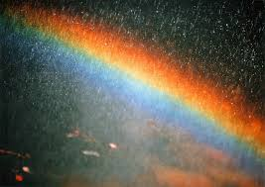
Today rainbows can be found in all sorts of places – in clothing, decorations and the symbol or moniker of various groups. But what about the significance of the rainbow in the sky? The science expalins a rainbow is formed by “reflection, refraction and dispersion of light in water droplets resulting in a spectrum of light appearing in the sky” as I read online @ http://en.m.wikipedia.org/wiki/rainbow. But do we know the Biblical and theological explanation? The Bible claims the rainbow was put in the sky by God after the flood as a sign of God’s covenant with Noah and his family, all their descendants, all the animals and the earth. God put the rainbow there in order that each time it rains and a rainbow appears, God is reminded of God’s covenant to never flood the earth again. What amazes me is that God made the covenant with not only the people but the animals and all creatures and even the earth itself! All were included and recognized as having been affected by and will now be saved from another flood.
Some might wonder or question God’s love for creation, given that God just drowned almost everyone and everything. But the story that precedes the flood in Genesis 6 tells of the sadness God was feeling toward the people as they excelled at wickedness. They were so wicked that ‘their thoughts and hearts were continually inclined to evil.’ God was sorry God had made these people and they grieved God to God’s heart. The corruption was nearly complete as the earth was full of violence, except for Noah and his family. This causes me to wonder, if the violence and the evil by these people was so terrible did they contribute to or help cause the flood somehow? Scripture only explains God determined to make an end to all flesh.
I look around today and I see a lot of violence, corruption, anger, hurt and hopelessness. I wonder what God must be thinking now. But the bow still hangs in the sky after a rainstorm as the suns comes out reminding God and us of God’s covenant to never flood the earth again- whether we believe God for this covenant or not! No matter the level of violence or evil, God promised never to flood our entire earth again.
Thankfully God has sent a different flood to earth. The sign of this flood comes in the shape of a cross. The cross sign signals a flood we cannot stop. This flood started much like the other one out of violence, ready or not. It was and is the flood of God’s mercy and grace that started flowing out of heaven, through Jesus on the cross, out through the Holy of Holies when the curtain tore in two and all over all of us.
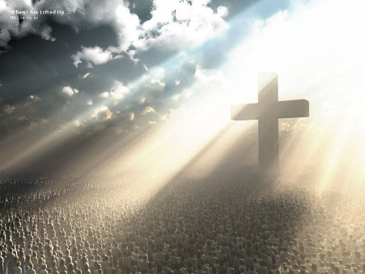
God, in Christ Jesus offers us a flood that saves and does not destroy. A flood that heals and does not hurt. A flood that takes away our dismay, discouragement, disease and distance from God, washing us up into God’s presence here in the Kingdom of God.
The cross is a sign of God’s goodness, the flood of grace available to all people, animals, and the earth for renewal, rejuvenation and reconciliation. This is a flood we can receive and share, splash about in and rest our hearts, lives and hopes in. So when the rains come, which we and our earth need, and you see the bow in the sky, remember the other sign, the sign of the cross and the new covenant in Christ that floods our hearts, lives and the whole earth with grace and love.

