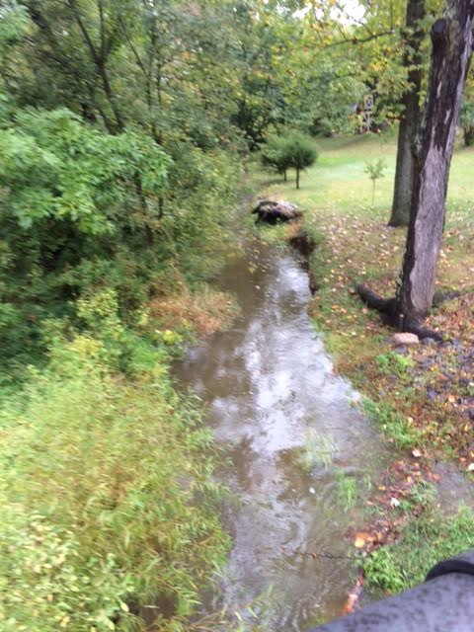
The Creek
I looked at the creek as I walked the dogs but there was nothing but rocks and dirt, not even a trickle of water. So dry. Everything was dry….then the rain began yesterday and with only brief lulls continued all night and on through today. Rain, constant rain is filling the creek with much needed water. The grass and the trees, stiff and dull brown, are soaked. We all need the rain!
When our world, ourselves are so dry, we need rain. We need the river of rain to reach us and fill us and cascade about us. Richard Rohr in his meditation on the Trinity talks about vulnerability. To be vulnerable is to open up to what we can’t control, to let the river not only flow into to me and you but to let it carry us away. To be vulnerable is to let what is happening happen to us, as scary as that may seem. Sometimes that means it rains for days on end. When we’ve become so closed, dry, and brittle; we need a deluge to upend our tight control and sweep us into the flow.
I like to think I’m flexible, easy going. But honestly I’m often fretting about whether I will measure up, whether things are going okay, whether I have the right answers for any given situation. Only when I step in the direction of One who gives the rain of grace and love and made those clouds to pour rain on my head, do I realize I am not at the center of all this. What is needed is for me to simply enjoy the rain washing over me, freeing me for whatever God would have me be. Otherwise I stand so rigid and hard, wet and cold trying to keep it all together, as the river full of grace washes right past me.
In his devotion, Rohr implied that to be vulnerable in our relationships is to become more like God’s lyrical, dance-like relationship of the Godhead - Father, Son and Holy Spirit. When we choose vulnerability we can more easily enter the dance, the place where Father, Son and Holy Spirit meet and commune in a whirl of motion. To dance means to allow myself to trust the One who has the lead. To marvel that the One who holds all time and space, invites me and you, wherever we are, to joyous dance and freedom. Invites us to wade deep in the river of grace and frolic in the dance of love and be vulnerable to what only God – Father, Son and Holy Spirit – can do in us. Then trusting God, we can let ourselves risk being real in our other relationships too for we know who holds us around the next turn.
The rain is still raining but I hear the call to dance. The call to let my fears and worries rest and join hands with the Dancing God who know the steps, who know the places I have never gone. All I have to do is open my heart to be loved, to embrace beauty and hope found in dancing with the One –Father, Son and Holy Spirit -who know me best of all and still welcome our thirsty souls to drink up and float into the ebb and flow of the dancing river of love.

Richard Rohr, Meditations@cac.org

