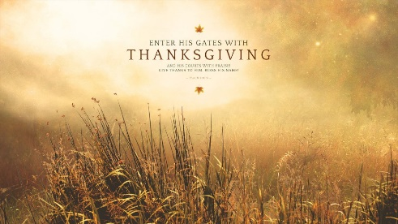
With Thanksgiving…
Coming back from being out of the country, especially when the one has been to a developing country, can change how a person views her life and experiences. Upon return from a 2.5 week visit to Ethiopia this past week, I now look at my life and experiences slightly differently. The ease with which I wash my clothes, the luxury of inside plumbing with hot water and flush toilets, the simple act of drinking filtered water from my refrigerator reminds me that I live a casual, very protected and easy life. This is not what millions experience daily in places where we traveled in Ethiopia.
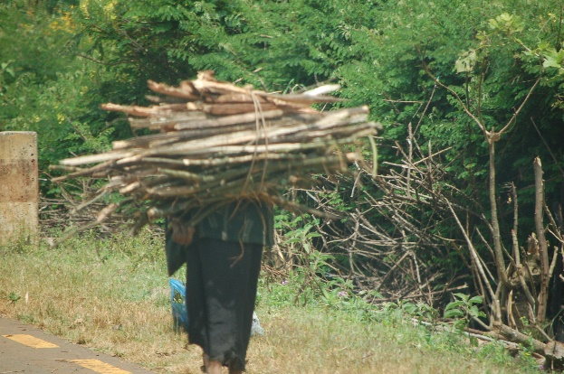
My daily life does not consist of building a charcoal or wood fire to have coffee or a meal. I don’t have to walk my animals to market to sell them and buy food. I don’t have to walk to wash my clothes in the river and then spread them on bushes to dry. I don’t have to carry a 5 gallon yellow plastic container to the nearest river or stream to collect drinking water so my family can survive. I don’t have to chop the head off the chicken so I can cook it and eat it. My house is not made from wood and mud with a thatched roof. I am not expected as the woman of the house to do all the work and carry large loads of sticks on my back so I can heat my home or build a fence around my property.
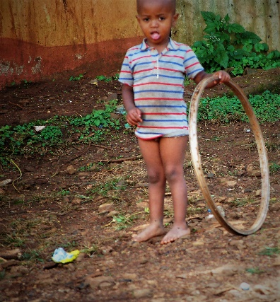
Instead I can drive to the store if I want to purchase anything. I dump my clothes and soap in a washer and then pop them in the electric dryer when they are clean. My clothes are many and children don’t walk about barefooted unless they want to. My husband shares in the work of the house and in bringing in the income we share. Our stove is electric and the wood we use is to build a fire in the fireplace just so we can enjoy it some evening.
This month I challenge us all to look at our lives with thanksgiving. But then to realize there are millions of people – some right around the corner from us and some thousands of miles away – who have so very little and yet are thankful for their lives, their children, their work and their God who loves them.
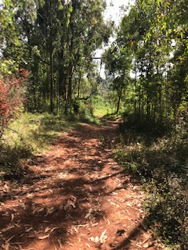
One Sunday morning in Ethiopia, I stood outside waiting to get in the van that would take us to the churches where we would be preaching. Where we stood was right by the path to the Metu Ethiopian Evangelical Church Mekane Yesus. The people going to church were not in cars or on bikes but walking to church. Some were quite old, some were even walking with crutches down the hill and up the steps to this church on a hill. They kept streaming past us walking to their church. The same was true at all the churches we visited. There were few cars at these churches, instead people walked on roads and on muddy paths to their church – some walking for miles.
I began to wonder about my devotion to my God and faith. Would I walk miles to church? I’m the pastor so I’m supposed to say yes! The second Sunday in Ethiopia I did walk to the church where I preached because the road to the church wasn’t a good one. So up the beautiful wooded hillside I walked on a muddy clay ‘road’ with my interpreter Qes Mengisto and Qes Yideta, another pastor who came along with us. Alongside us were two women, one was walking to church, the other was herding three calves up the hill, I presumed she was taking them to a place to graze. So you can imagine that the muddy track had more than mud on it as we walked along the way!
Is listening to God’s Word being preached and worshiping God in song and prayer worth walking to church, even if the way is rocky or muddy and we aren’t comfortable? Is the fellowship with other believers worth the time it takes? In the churches where I preached in Ethiopia- worship regularly lasts 2 hours- not including your travel to and from! Would our children walk to church on Saturday afternoon to choir practice to be ready to sing Sunday morning as the teenagers do at Metu EECMY?
I experienced powerful and passionate worship at those services. I experienced love and welcome extended to me simply because I came and preached God’s Word for 40 minutes (that’s how long a 20 minute sermon lasts with translation). And children were everywhere! So many families with children without an SUV to transport them to church -yet they all worshiped together and the children were blessed and prayed for. I sat amazed watching them put money in the offering bags extended on sticks down the long aisles of people squished together because there were too many to fit in the church building! I knew as I watched that many didn’t have much to give but give they did.
This month as we celebrate Thanksgiving let us rejoice! We have much to be thankful for and are gifted beyond our understanding. I am grateful to be back in America but my heart is still there with my brothers and sisters in Christ in Ethiopia. I am thankful to have had the opportunity to share worship with them. To God be the glory! Happy Thanksgiving from our house to yours!

