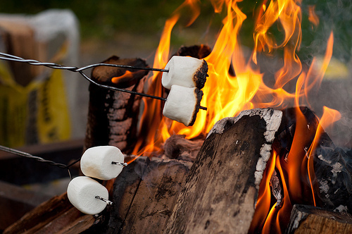
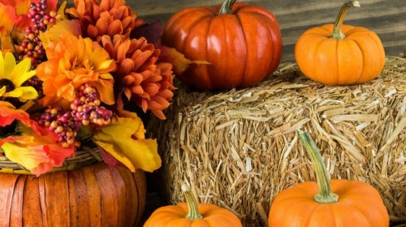
Fall Festival Make and Take
Bring your friends and family for the Fall Make and Take with a Pumpkin Decorating Contest, Trinitarian Candy Corn and Prayer, Hayride in the cemetery, Hot dogs and marshmallows, Door Prizes, Picture booth and more

Saturday Oct. 13
3:30pm-5:30pm
Gerrardstown Presbyterian Church
372 Dominion Rd. Gerrardstown, WV 25420
