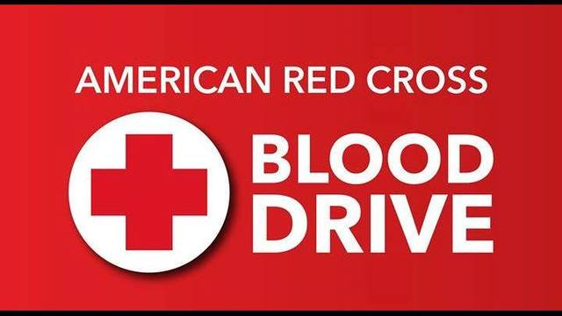
Blood Drive Wednesday Oct. 2 12-5pm at Gerrardstown Presbyterian Church
Fellowship Hall
318 Dominion Rd. Gerrardstown, WV 25420
Call 1-800-RED-CROSS to schedule a time to give blood or visit www.redcrossblood.org to schedule your appointment.

