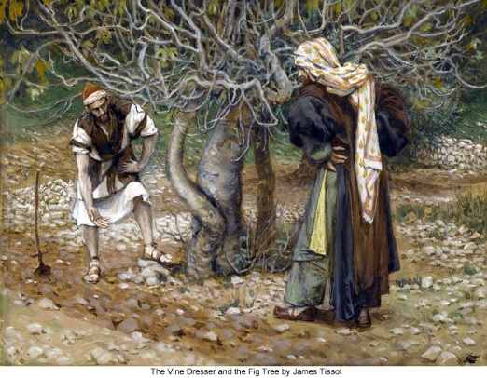
Gerrardstown Presbyterian Church Worship and Communion Service
8th Sunday after Pentecost
July 15, 2018
~We Gather~

Prelude
Welcome and Announcements, Joys and Concerns of the Church
Please sign the red Friendship pad in the pew and pass along to others.
Greetings: Stand and greet each other as music plays please take your seats to sing Gathering Song
Gathering Song #316 Where Charity and Love Prevail vs. 2
Prayer for the day
*Call to Worship (Psalm 13)
One: How long, Lord? Will you forget me forever? How long will you hide your face from me? Look on me and answer, Lord my God.
All: Give light to my eyes, or I will sleep in death, and my enemy will say, ‘I have overcome him’ and my foes will rejoice when I fall.
One: But I trust in your unfailing love; my heart rejoices in your salvation.
All: I will sing the Lord’s praise, for he has been good to me.
*Hymn of Praise #620 Praise, My Soul, the King of Heaven

~We Confess our Sin and Receive Pardon~
Call to Reconciliation: In our world today we see all kinds of tragedies up close through the media. How do we respond to the sorrow and hurt these disasters bring?
Prayer of Forgiveness: (Unison) Our Father, we confess it is easy for us to speculate how others may have sinned or displeased you to bring such sadness in their lives. But in truth, we don’t really know what caused their heartbreak. We repent of our suppositions about others and instead confess what we may be doing that displeases you …(silent prayer)
Assurance of Pardon: If we confess our sins, he is faithful and just and will forgive our sins and cleanse us from all unrighteousness (1 John 1:9 RSV)
All: Thank you Father that in Jesus Christ, we are forgiven.
*Gloria Patri #581
~We Hear a Word from the Lord~
Children’s Message
Hymn of Meditation #465 What a Friend We Have in Jesus
Prayer of Illumination
First Scripture Lesson: Job 4: 1-9
Leader: The Word of the Lord
People: Thanks be to God.
Sermon: Gardening with God: Fertilizer for Figs
Second Scripture Lesson: Luke 13:1-9
~We Respond in Joyful Service~
Prayers of Intercession
Call to Offering
Offertory
*Doxology
*Prayer of Thanksgiving
*Affirmation of Faith The Apostles Creed p.35
~We seal the Word in Sacraments~
Communion Hymn #415 Come, Ye Sinners, Poor and Needy
Words of Institution
Sharing the Bread and Cup
~We Go Forth to Serve~

*Hymn of Service #649 Amazing Grace vs. 1-4
*Charge and Benediction
*Benediction Response #649 Amazing Grace vs. 5
*Postlude
Tom Greenawalt, Lay Leader
Beverly Hughes, Organist
Rev. Karen Greenawalt, Pastor

*You are invited to stand

Welcome to Gerrardstown Presbyterian Church. We are glad you are here! If you are a first time guest, please fill out the Red Friendship pads in the pew. If you are a returning guest, we invite you to prayerfully consider GPC as a place to get to know and/or continue to grow your faith in Jesus in the Kingdom of God for restoration of mind, body and spirit through active discipleship (aka membership). For more information please talk to Pastor Karen or make a note on the Red Friendship pad.

Children are a vital part of our congregation. Each Sunday we offer Sunday school at 9:45am downstairs, a Children’s Message in worship and Children’s Church downstairs after the Children’s Message. Child care is also available in the nursery downstairs for all those 2 years and younger.

Coffee and Conversations meets at 9:45am in the Gathering Room. Read Chapter 21 of the Gospel of Luke for next Sunday.

The flowers on the Gathering room table were given to the glory of God and to commemorate the wedding anniversary of Kenneth and Dorothy Gladden Corbin. They were married in this church 40 years ago today by Dr Slider.

Upcoming Events- Mark your Calendars!
Tuesday July 31 – Free Community Dinner in the Hall from 4:30pm-6:30pm
NO WORSHIP SERVICE HERE IN THE CHURCH BUILDINGS SUNDAY AUGUST 12, instead we will enjoy a Worshipful Retreat and Potluck Lunch at Bob and Bev Hughes’ home in Shepherdstown.

HELP! If you know anyone in need of help with addiction or mental illness, WV has a 24 hour hotline 1-844-HELP4WV. The Suicide Prevention Lifeline number is 1-800-273-8255. If you know anyone who is having trouble paying a light bill, rent or needs mortgage help and other social services can be found by calling 211.

To Contact Pastor Karen please call the church office 304-229-2316 or her cell 407-619-2821. The church email is gerrardstpc@gmail.com , our webpage is http://gerrardstownpc.com/ . Like us on Facebook at Gerrardstown Presbyterian Church Life

Devotion for Sunday July 22, 2018

Read: Luke 12: 13-34

This advice sounds counter cultural doesn’t it? Most farmers build silos so they can store grain until they can sell it for the best price or use it later in the season. What is Jesus suggesting by the parable he offers in answer to his admonition to guard against all kinds of greed? What kinds of greed are there? Why does he give the disciples the admonition to not worry about life and food and clothes? How does Kingdom work differ from our daily needs? What are we ‘stock piling’? What are we trying to leave so there is room for others to glean?

Prayer: Father, we thank you for Jesus who knows better than anyone our inner motivations and our fears. We seek to be your Kingdom people and live and work in your Garden. What is it you want us to know and learn as we listen again to this parable today? If we are stock piling, would you show us how to make you our focus instead of our resources? We need your help for we are afraid. We confess we worry about whether we will have food or drink or a place to live and how will we be cared for when we are older. We seek to treasure your Son Jesus more than any other treasure on earth. In his name we pray. Amen.

