Gardening with God…
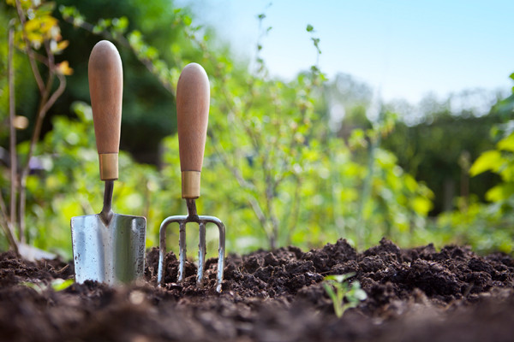
Dirt. A wonderful, general term for soil that looks radically different depending on where you live. I grew up in Illinois where farm land was known for being rich and plentiful. But in Florida where we lived, the land was mostly sand and needed some real garden soil to grow most anything. Here in West Virginia it’s rocky with clay so we use Black Kow for richness.
Our God is the Creative genius involved in all the creation we see. Scripture’s accounts of creation in Genesis 1 and 2 may seem a little different from each other but in reality they both agree that creation needed a Creator and that Creator was God.
In both accounts God creates a garden with trees and dirt. Scripture says, that God formed Adam from the dust of the ground. Adam is fitting name since Adam in Hebrew also means land. A little later we read that’s where Adam and all of us will return. Dirt holds the building blocks from which we are made and which gardens grow.
God had a purpose for Adam and Eve in this Garden of Eden, a purpose that reaches clear down to us today. God still has a ‘garden’ that we are still called to ‘til and keep’ though our gardening may occur in a more metaphorical way for many of us, except on weekends when we plant our tomatoes or annuals. While others, like farmers, ranchers or shepherds are actively participating in ‘tiling and keeping’ plants or animals daily.
I hope you will join me this summer as we, through the sermon series Gardening with God, will look again at scripture to see what we are called to ‘til and keep’ in our lives today.
Sermons can be found on our website gerrardstownpc.com. You will also find the bulletin for worship under the About Us tab under bulletins which will give the scripture, questions to ponder and prayer for the coming week. Or I invite you to come in person if you are here in the Eastern Panhandle of WV at 11am most Sunday’s except Aug. 12 when we will have our worship retreat in Shepherdstown, WV.
See you in God’s Garden!

