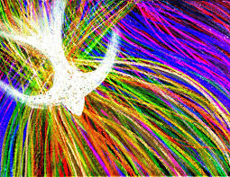
Pentecost
Make and Take
Celebration

Saturday May 19th
3:30pm-5:30pm
At Gerrardstown Presbyterian Church

Come discover the story of Pentecost in fun activities including wind and flames and flying kites!
Dinner will be served. Bring a friend!

Gerrardstown Presbyterian Church
372 Dominion Rd.
Gerrardstown, WV 25420
Church phone 304-229-2316

