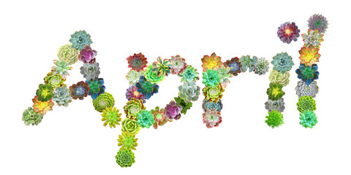
Gerrardstown Good News
The Best Foolishness Ever by Pastor Karen
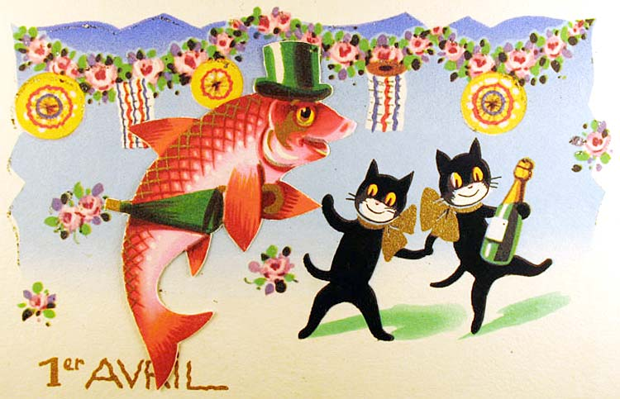
I was born on April 1st many years ago. It has been a wonderful birthday, albeit somewhat challenging at times due to it also being April Fool’s Day. My experience with this day is that it can bring unexpected and not always appreciated attention. This year April 1st is also Easter. Interesting combination Easter and April Fool’s Day!
Maybe it would be helpful to know how April Fool’s Day began. Well, the exact story is difficult to ascertain. Claire Powell and Dave Collett, who put together a little background information for those trying to understand the British culture, wrote this: ‘What is April Fool’s Day and what are its origins? It is commonly believed that in medieval France, New Year was celebrated on 1 April. Then in 1562, Pope Gregory introduced a new calendar for the Christian world, changing New Year to 1 January. With no modern communications, news travelled slowly and new ideas were often questioned. Many people did not hear of the change, others chose to ignore it, while some merely forgot. These people were called fools. Invitations to non-existent ‘New Year’ parties were sent and other practical jokes were played. This jesting evolved over time into a tradition of playing pranks on 1 April. The custom eventually spread to England and Scotland, and it was later transported across the Atlantic to the American colonies of the English and French. April Fool’s Day has now developed into an international festival of fun, with different nationalities celebrating the day in special ways.’
I don’t know whether you are a lover of playing pranks or someone who’s wary of being a fool, I admit, I am the latter. When our children were little, as soon as they figured out what April Fool’s Day was I told them since it was my birthday they were welcome to play pranks on anyone but me! And to their credit they allowed this day to be prank-free for me all these years.
I think one of my favorite April Fool’s Day stories, is the one my parents told me about. That last week in March, there was spring snow storm, not unlike what we just experienced here in WV. My mother was nine months pregnant and due any day. Drifting snow had caused the roads to close. They were snowed in. Thankfully, the weather warmed up by the end of week so that when my mother went into labor, she and my Father were able to get to the hospital in time. I was born on Friday, April 1st. This lovely story cheers me up when I wonder why I had to be born on the day of pranks!
This year I will share this illustrious day with the greatest foolishness of all! I really think God must have a delightful sense of humor. The dear women, Mary Magdalene and the others go to the tomb to properly prepare Jesus’ body only to find the stone already moved and no body there! They, of course were not laughing but were horrified and so very sad! Mary turns to the supposed gardener standing behind her and demands to know where he’s put him! What a sweet surprise to find out the Gardener was none other than the Risen Christ, her Lord Jesus! Sadness gives way to shock, gratefulness and wonder all rolled together. Thankfully, this was not a trick being played on Mary or the other women but a world changing event forever breaking the hold of Death and Evil overturning the notion that the Son of God could be overcome forever because of a cross with some nails and a spear to his side. Jesus proved there is nothing in heaven or earth or anything else that can separate us from the love of God in Christ Jesus our Lord. Nothing will ever destroy the Light of the World, the Living Water, the Love that is strong as death.
I am excited this year to share my birthday with Easter as we celebrate God’s Holy foolishness, Resurrection Day on the day of pranks, April 1st at Gerrardstown Presbyterian Church in Gerrardstown, WV. Hope you will join us in Worship at 11am!
March/April Events @ GPC

Thursday March 28th Maundy Thursday Service 7pm with Communion

March 30th Good Friday Prayer Stations in the Sanctuary and Prayer Walk in the Cemetery 7am-4pm

Easter Sunday Worship April 1st 11am
Community Dinner April 24th 4:30pm-6:30pm

You can watch the sermon videos online at gerrardstownpc.com or check out GPC on Facebook at Gerrardstown Presbyterian Church Life
Session Meeting Highlights
Monday March 26th Session continued their discussion of Success Is Who You Are, reinstated Charlotte VanMetre’s membership per her request; heard a report from Presbytery meeting, approved $1100.00 to fix the church roof; examined rolls and agreed to send letters to members who have not been active in hopes that they will return; planned a yard sale for June 23rd, approved the use of a monetary gift to the church for a year’s subscription to Right Now Media, a video library of Christian videos for Bible studies, Children’s fun and Christian learning, and marriages, families and training; approved a welcome reception for Nadia Ayoub our missionary on Saturday May 5th from 3-5pm; and approved final voucher submissions for where the donated missions funds should be distributed.
Thank you to all who made the Lenten Mission Project possible with donations for Homeless people and pets! This week Mary Campbell and your pastor took animal items to the Berkeley County Humane Society, any clothes to The Methodist Church Clothes Closet and the warm coats, hats, gloves, clothes, sleeping bags, sheets and blankets to the Boys and Girls Club of Martinsburg. The B&G will distribute their items April 18th between 10-2pm. They are looking for people to come and help that day. For more information contact Marge Ruth at mruth@regioneight.org.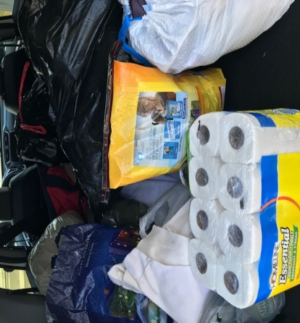
What is it? How do I access it? Who can benefit? Come Easter Sunday to find out!

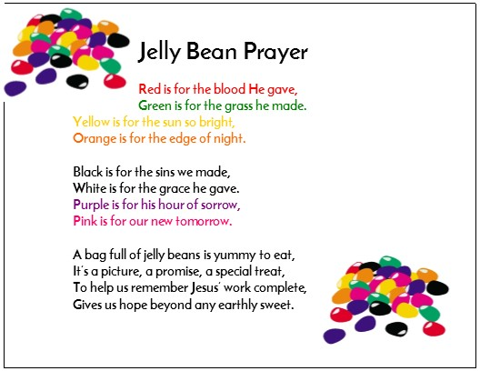
Easter Make and Take… at this year’s Easter Make and Take 27 children made a magnet with this prayer. As you fill baskets with jelly beans this Easter let this be your prayer…

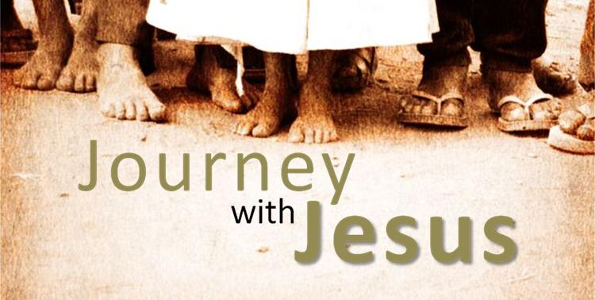
We have traveled over 3000 miles so far…but we aren’t there yet. This group of walkers and runners has agreed to continue our quest to reach Jerusalem by Pentecost. If you haven’t joined us and would like to contact Pastor Karen for more information gerrardstpc@gmail.com or 304-229-2316

If you know anyone in need of help for addiction or mental illness, WV has a 24 hour hotline 1-844-HELP4WV. The Suicide Prevention Lifeline number is 1-800-273-8255. If you know anyone who is having trouble paying a light bill, rent or needs mortgage help and other social services can be found by calling 211.

