What Makes You Stop?
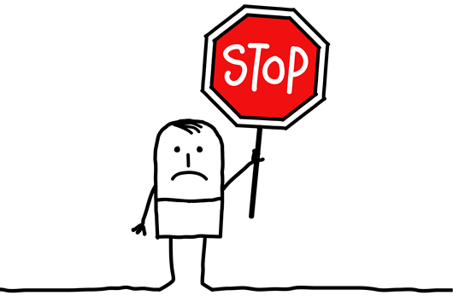
Brian Hershberg started picking up change when he was in college. He thought about all the overlooked pennies that people passed by because it was only 1 cent. He thought that if he picked up enough of these cents it would add up. And after 20 years he has accumulated $971.05 in change found on the ground.
I wondered to myself, ‘what makes me stop?’ For Brian it was money he found on the ground. This penchant for lost change even involved his wife and son at times. As I thought, I realized that I feel compelled to stop to pick up litter. I am saddened and sickened to see God’s world covered with wrappers, aluminum cans, bottles and cigarette butts. I remember encouraging our children to always put their trash in the garbage can because this was God’s world which was never meant to be covered with our debris.
Then I wondered ‘what made Jesus stop?’ As I read the Gospels, I noticed that Jesus stopped for people – like the children, whose parents wanted him to bless them, which Jesus did, even though the disciples tried to stop them from coming. Jesus stopped to find a person who had touched him. It turned out to a woman who had been sick for years with a flow of blood and had secretly touched the hem of his robe. He stopped to assure her that her faith had made her well. Jesus stopped for a man who was so wild and hurting, that he had to live in the tombs because he kept breaking the chains in which people had shackled him try to stop him. Jesus freed him from the chain of demons on the inside and he no longer hurt himself or anyone else. Jesus stopped for a lonely woman at a well, two blind men who wanted to see, a Syro-Phoenicain woman with a child in need, a tax collector in a tree and many others when he walked this earth.
Through the next several weeks Gerrardstown Presbyterian Church is counting our steps and our hours of worship, devotion and service as we Journey to Jerusalem with Jesus as part of our Lenten Discipline. We are adding our miles together trying to ‘walk’ the 5922 miles, the distance from Gerrardstown Presbyterian Church in Gerrardstown, WV to Jerusalem in Israel. Everyone is welcome to join us. Just email Pastor Karen at gerrardtpc@gmail.com to receive your number and devotional packet and join us.
As we walk, I would invite us all to see not only coins or trash that need picking up, but the people in our path that need us to notice them just as Jesus would. May we ‘pick them up’ with a smile, a kind word, by listening to their story or sharing a prayer to lift their spirits and invite our Lord into their situation. The investment is small but the dividends will be much more valuable than $971.05.

https://www.wsj.com/articles/what-ive-learned-from-my-quest-for-loose-change-1518097853

