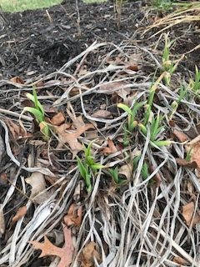
Signs of Life
It’s almost March. I’m ready for spring! How about you? I went on a hunt to find signs of spring… I didn’t have to go far. There were buds on the tree just outside my door and some early signs of Jonquils and Tulips a little bit up the walk. There were signs of perennials coming back to life and even some grass and weeds looking very green. No matter what the temperatures tell me, spring is pushing its way through the earth and out to the edges of the tree limbs.
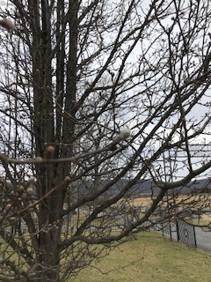
What about you and me? Where are the signs of life springing up in us? Well if you are reading this that means you woke up today and are breathing! You are alive! But how about your spiritual life? What are the signs of life there? It’s easy to read a scripture, pray a few prayers for others and go on our way or just wing a prayer and move on with our day. Are we really alive to the Spirit of God who often speaks so quietly we won’t hear, unless we are listening carefully?
Our life signs may not be as green or as fruitful as we’d like. Jesus told us the fruit that overflows out of our mind and mouth is the result of what is in our heart. (Matt. 15:18-19) What kind of tree or plant are we becoming? Are we an Oak of righteousness or a bramble bush all sticky and dry? Or could we be a tree planted by the streams of water sinking our roots deep? If I am honest I sometimes find that my roots are pretty short and my temper likewise. I pray often for a change of heart and to have the joy of God’s salvation restored in me. (Psalm 51:12)
There is a passage in Jeremiah that speaks to these signs of life: “Thus says the LORD: Cursed are those who trust in mere mortals and make mere flesh their strength, whose hearts turn away from the LORD. They shall be like a shrub in the desert, and shall not see when relief comes. They shall live in the parched places of the wilderness, in an uninhabited salt land.
Blessed are those who trust in the LORD, whose trust is the LORD. They shall be like a tree planted by water, sending out its roots by the stream. It shall not fear when heat comes, and its leaves shall stay green; in the year of drought it is not anxious, and it does not cease to bear fruit.
The heart is devious above all else; it is perverse-- who can understand it? I, the LORD test the mind and search the heart, to give to all according to their ways, according to the fruit of their doings.” (Jer. 17:5-10 NRS- emphasis added)
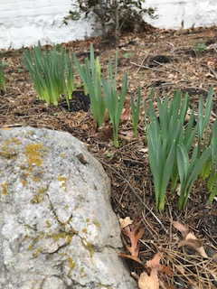
Thank goodness Jesus came to overcome the curse! He invites us to join him and those others who also want to bear much good fruit as we wait upon the Lord, trusting in God praying and worshiping together, letting God be our trust! This trust must be very important if Jeremiah repeated it! As Christ’s followers come together, we trust God in Jesus, we don’t have to worry or fret about things. Instead we can seek the Lord about them, entrusting to God what is beyond us and together giving him our praise and thanksgiving.
At times we may need to admit our wayward hearts and dry fruitlessness, then God can work a miracle in us through the cross of Jesus where all the selfish intentions we carry were crucified with him. Therefore, even though Easter is weeks away, we can even now receive his resurrection light and life in our souls and hearts today. Jesus can eradicate the hard, lifeless parts as he fills us with his living water that will irrigate and grow the seed of trusting faith so we will produce good fruit in how we think, speak, and act. Just like the plants and trees that are showing signs of spring surging in their buds and branches, we can be like the trees planted by streams of living water. And if we search, we may find signs of trust and beginning of fruit in our lives.

