Peace and Goats
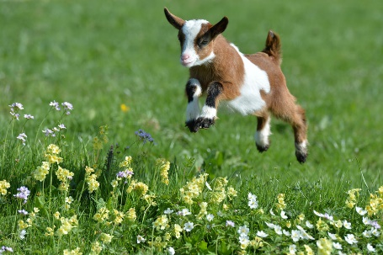
This is Advent. Are we are nearly ready for Christmas. Tree up? Check! Tree decorated. Check! Presents bought…still working on that one! Living with peace?? How are we to do that when the problems are so big and the solutions seem so limited. The angels proclaimed ‘Peace on earth, good will to all those that God favors.’ Makes me wonder who God favors?!
This Sunday we will contemplate the word peace, the word we highlight as we light that second candle on the Advent wreath. What does Advent have to with peace and with Christmas?’ Jesus has been here and gone. Why do we need to light candles to await the advent of what’s already happened? As Christ followers we believe Jesus will come again as scripture tells us in Acts 1:11. “They [angels] said, "Men of Galilee, why do you stand looking up toward heaven? This Jesus, who has been taken up from you into heaven, will come in the same way as you saw him go into heaven." (Acts 1:11 NRS) So we wait, not only for this Christmas holiday that is coming as we celebrate Jesus’ birth, but also the day only known by God when Jesus will come back to earth.
While we wait, we light candles, we pray, we sing and this week we think about peace. How is it that the Prince of Peace came and still there isn’t much peace in our world? How is it that the Body of Christ, the Church doesn’t always seem to be at peace within themselves? How is it that something as simple as young goat might bring peace to lives of people we don’t even know?
This Sunday the children and I will talk about this important topic of peace and goats (or other animals). There is a wonderful organization called Heifer International that offers peace in the form of goats, chickens, llamas, water buffalos, alpaca, fish, rabbits, pigs and yes, heifers as their name implies and much more. You can find out much more at their website https://www.heifer.org/gift-catalog/animals-nutrition/index.html?msource=KIK1j16GP1008&gclid=CjwKCAiA6qPRBRAkEiwAGw4SdsiWQJhd_ux-3CviYiorgpK5Qs6KQNji6TZqckpaDV4KoxCkHaqDUxoCukQQAvD_BwE
This might be the most important catalog you browse through this Christmas. A small animal given to a family who receives good instruction on how to care for and keep this animal and then share one of the offspring can make all the difference for peace in a family, a community and ultimately, the world.
I can’t promise live goats in worship, but I can promise we will sing, talk and worship Jehovah Shalom, our God of peace and Jesus, the Prince of Peace this Sunday and learn how we can live with peace and be active in offering Jesus’ peace to those near and far.

