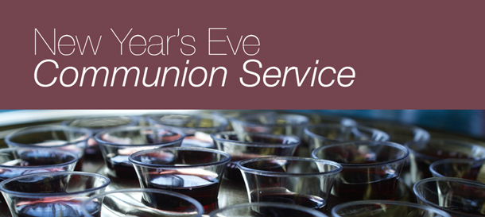
Please join us for Worship and Communion on Sunday Dec. 31st at 11am
Gerrardstown Presbyterian Church

