Gerrardstown Good News

While We Are Waiting by Pastor Karen
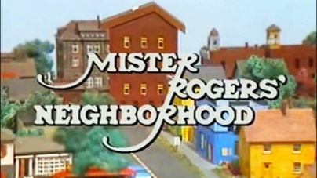
Do you remember or did your children ever watch Mr. Rogers’ Neighborhood? If so, you may have heard his song “Let’s think of something to do while we’re waiting” http://www.dailymotion.com/video/x3659il
Mr. Rogers was one of the programs that our oldest girls watched when they were allowed to watch TV when they were young. I loved the quiet and comforting life in Mister Rogers’ Neighborhood. I also liked that Mr. Rogers did not shy away from the challenges that children face daily, because these very same things are what we face as adults. All we have to do is read the papers or watch the news to see that people are hurting, lonely, scared, alienated, sad, and don’t have a way to express or handle what they are experiencing. Maybe we didn’t all watch Mr. Rogers because maybe we didn’t realize how helpful it can be to watch a kind minister turned children’s TV show friend and neighbor.
The Christmas season is upon us whether we cherish it or would rather wish it away. It is here. In the church we call this time Advent- a time of waiting. ‘What are we waiting for?’ is a question I like to ask the children. But it is also a good one for us adults to ask ourselves. What are we waiting for? Waiting for the hubbub to die down? Waiting for our paycheck or retirement check so we can go shopping? Waiting for family to come or for family to leave?! Waiting for surgery or to finally be healthy again? Waiting for…?
Waiting is what Advent is all about….waiting for Jesus’ return. Maybe Mr. Rogers’ song ‘Let’s think of something to do while we’re waiting’ is appropriate for us to consider now or every day of the year. For all of our lives we are waiting for something or someone, especially if we believe Jesus will come again. But as Mr. Rogers says in the song:
Let's think of something to do while we're waiting
While we're waiting for something new to do.
Let's try to think up a song while we're waiting
That's liberating and will be true to you.

Let's think of something to do while we're waiting
While we're waiting 'til something's through.
You know it's really all right;
In fact, it's downright quite bright
To think of something to do
That's specific for you.
Let's think of something to do while we're waiting.

As people who claim Jesus as our Lord and Savior, we really do need to consider what we are doing while we wait during this Advent season and all year through. Maybe we need to first think about the fact that we are waiting! We may have gotten so caught up in everyday life and our worries that we have forgotten.

This month in worship at GPC we’ll be considering waiting and what we can do while we wait. We’ll light the traditional Advent candles of hope, peace, joy and love and then consider how these four could possibly be things we can be an important part of our waiting now and all year long.
I challenge us during this Advent Season, the beginning of the church year and the end of the secular calendar year, to ask ourselves ‘what will I do as I wait?’ Will I be involved in a liberating activity, a healing activity, a kind activity, a hopeful activity, a peaceful activity, and/or a loving activity? Something specific that is life-giving and maybe long overdue? Will I encourage others to join me in this activity?
I invite you to come and join in worship on the first three Sundays of December at 11am and on Dec. 24th, Christmas Eve to come to our only service – our family worship service- at 4pm, as there will be no 11am worship service that day. Then start your New Year off right by coming to worship on New Year’s Eve at 11am as we receive the Lord’s Supper. Maybe, just maybe if we consider hope, peace, joy and love this month, then we will realize Who goes ahead of us into 2018, even Jesus our Lord and Savior, lighting our way as He leads us to find what we will do while we wait.
You can also watch the sermon videos online at gerrardstownpc.com or check out GPC on Facebook at Gerrardstown Presbyterian Church Life

Here are ways you can be involved in local missions:
Rescue Mission needs Christmas Cookies and small wrapped gifts for men. Please bring items and place in barrel in Gathering Room behind the Sanctuary.
BackPack Items Needed Soon! Please bring as many items as you can this Sunday Dec. 3rd to fill our two baskets.

Food basket Items:
canned ham - 16 oz
canned chicken - 12.5 oz
corn - 28-38 oz can
instant potatoes - 15 oz box
stuffing mix - 6 -10oz box
egg noodles 12-16 oz bag
cake mix and canned icing
peanut butter - 28 oz
jelly - 18 oz
powdered drink mix 18-20 oz
quick oats
family size cereal

Household basket items:
liquid dish soap
laundry detergent
all-purpose cleaner
bars of bath soap nor body wash
toilet paper
toilet cleaner
paper towels
]tissues
trash bags
shampoo
deodorant
band-aids
antiseptic cream
toothpaste and tooth brushes pack

Christmas Help for Community Families: If you would like to help with monetary expenses for a couple families in need, please write a check or give cash to GPC with Christmas for Families in the memo line or on the envelope. These gifts will allow the church to provide for expenses for these families during the Christmas season.
November Session Meeting Highlights:
Session approved the collection of socks and sponsorship for the Faith Community Coalition for the Homeless and Good Samaritan Clinic Keep the Faith 5K Nov. 11th. We had 3 members of GPC participate in this event and the GPC collected a box of socks to donate.
Elder Training and special Session meeting was held Nov. 6th . The new elders were examined and their examination sustained, and installation approved by Session. Installation service for Patty Oester and Mary Campbell will be Sunday Dec. 31st 2017.
Session approved the name change from Lecture Room to Gathering Room for the space behind the sanctuary. Nominating Committee brought forth a nominee, Judith Becker, as trustee and will bring this name to Congregational meeting in 2018.
Session approved up to $1500 to replace a radiator in the Manse that is beyond repair.
Session approved giving Shenandoah Presbytery $44.01 per member which totals $1672.76 for 2018. Session began work on the budget for 2018 and will meet with Joe Sturm in December to finalize details before approving the new budget.
DECEMBER EVENTS
Sat. Dec. 2 – Church Family Fun-3:30-5:30pm in the Hall
Sun. Dec. 3- 1st Sunday Advent 11am with Communion and Fellowship with snacks in the Gathering room following worship
Sun. Dec. 10, 17 – Worship 11am
Sun. Dec. 24 – One Family Candlelight Christmas Eve Service at 4pm
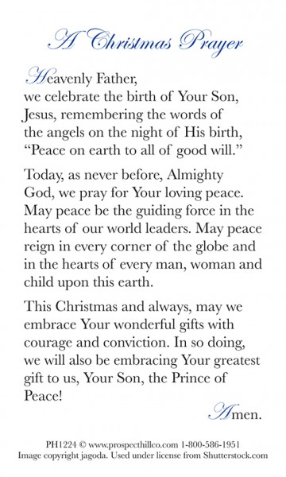
Sun. Dec. 31 – New Year’s Eve Worship 11am with Communion and Installation of new elders

Christmas Family Fun!
Saturday Dec. 2nd from
3:30pm-5:30pm in the Hall.
There will be pizza and cookies, ornaments to decorate, Navitity sets to make, Christmas songs, videos and a Christmas picture booth!
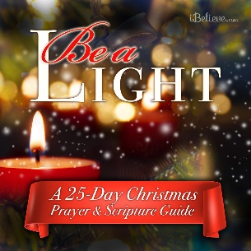
Hope to see you there!

Click on the link below for a Christmas daily prayer challenge beginning Dec. 1st. Although each day may not resonate with each of us, it offers plenty of ways we can redirect our hearts to Christ during this busy season. https://www.ibelieve.com/faith/be-a-light-a-25-day-christmas-scripture-and-prayer-guide.html

