Gerrardstown Good News
August 2017

Don’t Come To Church This Sunday August 6th!!
Instead go to Bev and Bob Hughes’ home at 11am for Worship and Fellowship!
All are welcome! Dress will be casual and relaxed. Pool will be open. Menu is Fried Chicken, ham and Bob’s baked beans, drink and birthday cake (Happy Birthday Bob!) Please bring appetizers, casseroles, salads or desserts to share. In case of inclement weather, we will meet in The Hall. Hughes’ address: 456 Berridge Dr. Shepherdstown ph.304-876-3093
God’s Best Interpreter by Pastor Karen
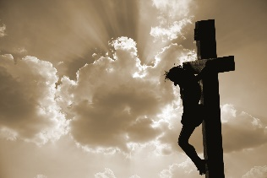
I remember years ago I attended a meeting of church leaders which included worship. The preacher that day was a Korean pastor. When he stood up to speak, he spoke in Korean, which I could not understand. But next to him was a younger man who then interpreted for us what the older pastor had to say in English. It was so interesting to hear the beauty of the Korean language and then really hear what was being said so we could not just marvel at the sounds but understand the meaning behind his words.
When I studied in seminary I learned Hebrew and Greek so I could interpret the scriptures. It was difficult though, because even though I could look up these words in a lexicon, a dictionary of sorts, some meanings of words were sort of mysterious and didn’t translate very well into English. Not only was I learning words from other languages but I needed to learn about the culture of the ancient Jews who spoke and then eventually wrote the Hebrew portion of the Bible, from right to left, that we call the Old Testament. Because it is such an old language and the early writings are lost, no one knows how to say the name of God. The pronunciation was lost because the Jews neither spoke it nor wrote it.
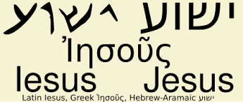
There is much more we need to know about God beyond how to say God’s name – is it Jehovah or Yahweh? Thankfully God sent the best interpreter God had, Jesus. Jesus came speaking Hebrew or a version of Hebrew called Aramaic. But what was more important than Jesus’ language were his actions. As Jesus said when he was talking with his disciples as recorded in the Gospel of John 14:7-9, “If you know me, you will know my Father also. From now on you do know him and have seen him." Philip said to him, "Lord, show us the Father, and we will be satisfied." Jesus said to him, "Have I been with you all this time, Philip, and you still do not know me? Whoever has seen me has seen the Father.”
The more I have studied and continue to study Jesus, I continue to be amazed. Jesus was not just a Jewish rabbi or prophet but when I look closely at what he did, I see he was the Son of God and Messiah. He showed us by how he lived, to whom he talked and ministered- who God is and what is important to God.
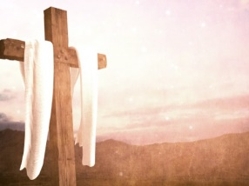
Jesus challenged not only his disciples in the way they saw or thought about God, but also many of the Jewish religious leadership. They watched him and saw the wonders he did and yet refused to believe he was the Messiah. They clung to their power and prestige and their view of the Law. They did not try to understand instead they killed Jesus in order to silence him and the kingdom he claimed to bring to earth.
But Jesus showed them God when he could not be held by death but instead conquered death in the resurrection, setting the Kingdom of God loose in this world. Then Jesus invited and empowered those who followed him to continue to challenge the death-giving aspects of the darkness that lurk in our world and to shine his light giving glory to God through the message of the cross and resurrection.
I wonder how people today interpret scripture and their experiences as they try to understand who God is. Are we like the scribes and Pharisees who want to decide our own view of God? Or are we willing to let Jesus re-interpret scripture, especially the Old Testament and answer the questions we have about the troubling aspects of our lives?
One example that points to Jesus unique interpretation of God is seen when Jesus’ disciples asked him about a man born blind. (John 9) They wanted to know who sinned this man or his parents. Jesus said neither. This happened so God could be glorified and then God was glorified as Jesus healed the man of his blindness.
What other tragedies could we insert in place of blindness in that question? Who sinned that caused someone to have cancer or arthritis? Who sinned that caused floods and hurricanes or earthquakes? Who sinned…?
Jesus saw the brokenness of the world around him and showed us the answer was restoration which glorified God. How did Jesus do this? He showed us God’s will is for all to be made whole, in order for the world to be welcoming not a fearful, disastrous place to live. Jesus came bringing the world of heaven to earth (aka Kingdom of Heaven or Kingdom of God). Notice all Jesus did next time you pick up your New Testament. He healed, he spoke words about living and life, he changed water into wine so the wedding party could go on, he held children and blessed them, he fed people, he calmed raging spirits, winds and seas, ate with and healed more people, cleared out the Temple so prayer could resume and forgave people. But this didn’t stop with Jesus. His disciples went on to do the same and teach others to proclaim the good news of the Kingdom of God.
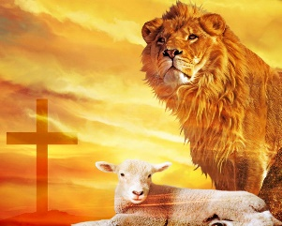
We need not despair as we see the chaos and disasters in our world. Instead, I would invite us to remember God’s best interpreter Jesus who showed us restoration and redemption is for all of the people and all of God’s world -through the cross. Jesus is still at work. He is looking for a few more disciples to follow him, to help interpret this great good news of God and the restoring Kingdom of heaven.
To learn more about following Jesus and the restoring Kingdom of Heaven contact Pastor Karen at GPC 304-229-2316
Mission Made Possible By You!

Helpers needed with the packing of food for the school children in the area. Packing dates are:
August 10
Volunteers are needed at 9am on the above dates at James Rumsey Technical Center on Hedgesville Road. Enter through the side door from the parking lot. If you can’t pack, are you willing to donate food? They accept ‘kid friendly’ foods such as microwaveable pasta, mac ‘n cheese, canned pasta and soups. Also nonperishable cereal, juice, pudding cups, cookies, pouches of tuna or chicken, pancake mix (just add water type) and syrup. Bring to church and it will be delivered.
The 2017-18 school begin! Aug. 16 for teachers and Monday Aug. 21 is the first day back for students.
We are again collecting school supplies for Gerrardstown Elementary School. Please bring any of the following supplies and/or a back pack to church by Sunday August 13th.
Kindergarten: Crayons, large box tissues, 4 glue sticks, backpacks with shoulder straps no wheels, 1 composition book (hard cardboard no spirals)
First Grade: Book bag, 2 boxes crayons (no more than 24 count), 2 packs of pencils, scissors, extra erasers, 2 composition books (hard cardboard coverbound), 2 packs of glue sticks, 2 boxes of tissues
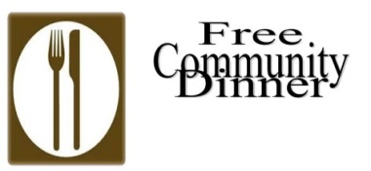
Second grade: 3 pkgs pencils, 2 boxes tissues, 2 packs of 24 crayons, 4 glue sticks, 1 composition notebook, 1 zippered cloth pencil pouch (not plastic box), 1 pkg wide-ruled loose leaf notebook paper
Next Community Dinner August 29th from 4:30pm-6:30
GPC July Session Highlights
Session heard a report from the treasurer that our income was slighty ahead of budget predictions for the first half of the year and a report from the clerk about the special Presbytery meeting held on Tuesday July 18th at which Presbytery approved the motion by the Warm Springs Adminstrative Commission to dissolve Warm Springs Presbyterian Church with about roughly $310K to be paid to Presbytery from WSPC assets and Session is working with Joe Sturm to plan and holding a blood drive, possibly in September. Session approved a new GPC wedding policy for members and nonmembers, revised Terms of Call for Pastor Karen, accepted a gift from an anonymous donor and sent a thank you note to Mr. and Mrs. Wayne Doyle, former members of MWPC in Florida where Pastor Karen served, for a gift of $500 to the GPC. Active Session Elders: Harriet Kopp, clerk, Glen Sherrard, Stephen Zurenda.
Coffee and Conversations The adult Sunday discussion group has taken a short break for the summer but will resume Sunday August 27th at 9:45am. Everyone is welcome! No prior knowledge of the Bible is required. Just come have a cup of coffee or tea and join us as we grow in our faith and understanding. We will be reading and discussing the Gospel of Mark using Mark for Everyone by NT Wright (order your copy now!).
Save the Date –Thursday Aug. 24 Dreaming and Planning for GPC
Fellowship Hall 7pm
All are welcome!
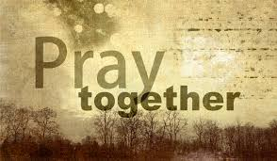
Please join us in prayer for: Family and Friends of Grace Weekley, Family and friends of Paul Boyd, Judith Becker, Michael Roberts, Ryan Hart, Arlene Rose, Sheila Brookman, Anna Shaffer, Susan Fronck, Connie, Marilyn, Sandy Lewis, Michael Campbell, Bill and Janet Starr and son-in-law Matthew Baynes and family, Donald Richter, Regis and Betty Knauff, Eileen Pettersen, Gerrit Myers, Mike Jessup, Allen Martin, Curtis Butts, Janet Sherrard, Dick LeDane, Amelia Sturm, Samantha Oester, Jim Butts, Kenda Butts, Leonard McDaniel, Linda Stillwell, Peter Housel, those struggling with addictions and their families, those who are grieving and those who are incarcerated.

Construction has begun on a handicap accessible bathroom in the Church building in what has been often called the ‘Lecture room.’ This room is covered with plastic. Please try to avoid this area is possible. If you have any questions please contact Tom Greenawalt who is the liaison to the contractor. Tom’s cell phone 321-422-9575

Like us on Facebook at Gerrardstown Presbyterian Church Life. Check out our web page at gerrardstownpc.com. Watch GPC sermons on our YouTube channel at
https://www.youtube.com/channel/UCLfSklx6M0fTP67LLAijmuw

