How Can We Make It Happen?
Have you ever tried to ‘encourage’ your toddler or teenager to do something? It may have been a task like cleaning up their mess or taking on a task that she needed to do. But the more you wanted her to do it, the less she wanted to comply. It’s a strange phenomenon – the art of encouraging but not badgering.
I find that as I study the Kingdom of God and it’s coming here on earth; as I explore how the Kingdom comes – it doesn’t happen through insistence. I cannot demand the Kingdom come now. I can’t make it happen by sheer will. The Kingdom cannot be manipulated or coaxed, which are often two sides of the same coin. The Kingdom is God’s. It is heaven in so many ways, which came to earth in Jesus, the Christ. Jesus left the Kingdom- coming process to those he’d chosen when he went back to heaven. If we say we follow Jesus, then we are also invited to become a part of the Kingdom-coming process.
I wonder how that is going for you. It is glorious work but not something we ‘do’ as much as it is something that comes as we trust. As we learn to know God in and through Jesus, we begin to realize the Kingdom is what God does here and brings here through the work of the Holy Spirit. Our job? To expect it! To trust God’s Kingdom-coming ways. To assist by seeing our place in the Kingdom here on earth.
This may sound like a dream but it is reality and the work is all around us. Maybe we have forgotten Jesus’ daily Kingdom-coming activities. He walked, talked about heavenly realities in an earthly way and ate with the disciples. He taught and preached about the Kingdom coming to earth. He ate with and visited outcasts, and he healed those with suffering from afflictions and diseases or demons who had a mustard seed of faith. And many were amazed and enjoyed his presence with them. He sent the disciples to go and do the same. Then he gave his final thoughts, which included the promise of the Holy Spirit so that all who follow him would do the same, and he died on the cross and rose from the dead, to make the grace and the love of Kingdom available to all!
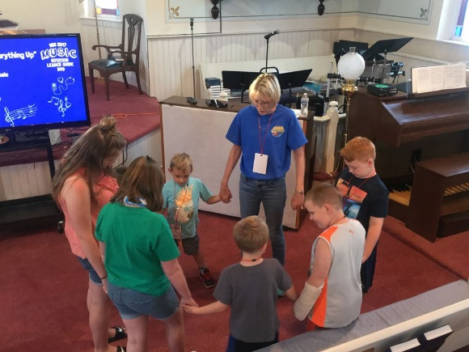
But how do we take part in this Kingdom-coming process? If we remember Jesus with the little children, he talks about receiving the Kingdom: “People were bringing little children to him in order that he might touch them; and the disciples spoke sternly to them. But when Jesus saw this, he was indignant and said to them, "Let the little children come to me; do not stop them; for it is to such as these that the kingdom of God belongs. Truly I tell you, whoever does not receive the kingdom of God as a little child will never enter it." And he took them up in his arms, laid his hands on them, and blessed them. (Mk. 10:13-16 NRS)
How do we become like little children – not throwing tantrums to get our way – but with simple expectation of the One who loves us completely. Often this involves prayer time with Jesus, knowing and receiving deep in our hearts what Jesus says in scripture. It includes trusting who God really is as we see God at work in Jesus’ life – talking, preaching, teaching, and healing. It means humility at realizing we are given the chance to stand in God’s presence with another, thanking God for Jesus, for the finished work of the cross for healing that we can experience today because we trust God has done it (see Isaiah 53:3-5). Then all we need to do is receive what God in Jesus has already done. The Kingdom comes as we offer the truth of the cross and Jesus and God in glory.
It doesn’t come because we tell it to or insist but because we trust it to come, like a little child, as Jesus promised. We come to honestly expect that Jesus does the will of the Father which is healing and wholeness- not because of who we are but because of who God is and what God does in and through Jesus.
Thankfully the Kingdom of God is a beautiful reality and will not throw a tantrum or stomp out the door. The Kingdom is God’s great love for us, the delightful heavenly reality of God’s closeness and healing right here – right now.
To know more I invite you to join In His Footsteps, a Kingdom Healing video course, ongoing on Wednesday evenings at 7:30pm online. If you want to know more, email me kgreenawalt1@gmail.com

