What’s Your Abundance?
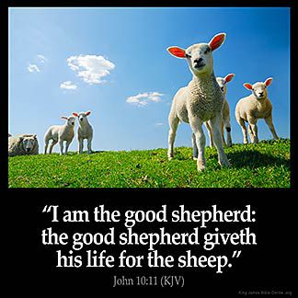
When we think of abundance we often think in terms of possessions –how much stuff do we own? I remember years ago Imelda Marcos, the wife of Ferdinand Marcos, the President of the Philippians, had an overabundance of shoes, which are now in a museum. But when Jesus talks about abundance he was talking about sheep, God’s people. He offers them life by laying down his life in defending them from harm. (John 10) “The thief comes only to steal and kill and destroy. I came that they may have life and have it abundantly. I am the good Shepherd, the good shepherd lays down his life for the sheep.” (John 10:10-11) I don’t think Jesus was talking about abundant life in terms of us collecting as stuff as we possibly can.
Jesus lived life abundantly but did so with very few possessions or even a permanent residence. He was an itinerant rabbi who moved from place to place teaching and preaching through the help and kindness of others. The Prophet, John the Baptist proclaimed that if we had the abundance of two coats we should share one of them and if we had food, we should share that as well. (Luke 2:11) What then is this abundance Jesus wants us to have?
If we look at Jesus’ life we see he came to the people of God to teach them about living life in the Kingdom of God, i.e. God’s way and Jesus healed them. He healed people who were sick, lame, blind, deaf, acting strangely (demon possessed), and even a few who had died. He ate with many people who weren’t invited to dinners by others. He be-friended children and blessed them. And he told stories and more stories of what abundant life looks like in the Kingdom of God. He invited people to come along and he taught them to do the same as he was doing.
I wonder of what we have in abundance? Is it happiness, sadness, laughter, tears, faith, doubt, love, hate, boredom, busyness? Do we have excess stuff or not enough stuff? Is our cupboard bare or overflowing? What can we part with and what must we keep? What of this stuff gives us life? And what is dragging us down? What offers us life? And what is trying to kill and destroy our life? What does abundant life look like?

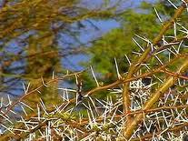
Jesus often told us not to worry about life. He said the gate is narrow that leads to life. Those who find their life will lose it and those who lose their life for Jesus’ sake will find it. Sometimes it’s the ‘cares, riches and pleasures’ that choke the life out of us.
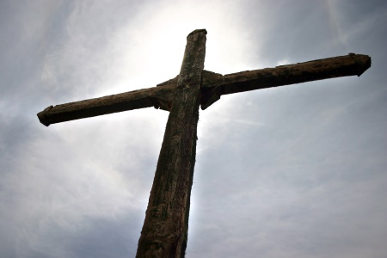
What about our life? Do we have life abundant? If so, what can we share? Because if we have an abundance – we are invited to share out of our abundance, that was what Jesus did! He had an abundance of faith, love and grace so he shared God’s healing with those who needed it. He had an abundance of love and kindness so he cared for the little children and the tax collectors that nobody cared for. He had an abundance of wisdom so he taught and preached the Word of God. He had an abundance of love and mercy, so he went on the cross to take the sins, the sorrows, the afflictions, diseases and pain that by his wounds we are healed (Isaiah 53). We can live abundantly because Jesus took on all that would kill or destroy us.
If life does not seem abundant right now or we are feeling discouraged, we may need to look at our lives carefully with Jesus to see what Jesus sees there. What can we give up? What can we add? Is Jesus our priority? If we turn to the Good Shepherd of the sheep who gave his life for us, Jesus offers us another chance to begin again and find life abundant in and with him.

