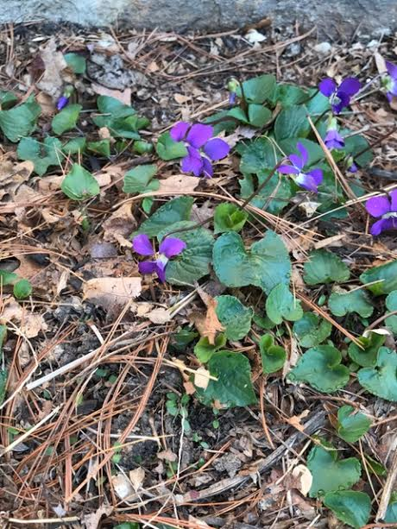
Be Beautiful Anyway
The other day I was walking to my office when out of the corner of my eye a tinge of purple caught my attention. There at the bottom of the front wall were some violets amid the pine needles and leaves. They were growing and blooming without anyone’s notice. I have no idea how long they have been there because I’d never noticed them before! And yet they were simply beautiful.
I began to ponder this hidden beauty. Why should little violets bloom even when no one is watching except for the doves that are probably building a nest in the bush above? Why bloom so pretty when the world rushes on and not many people come by this space between the hedges?
The other day I noticed someone else as I was getting my mail. Coming up the road were a couple of men. So as I turned I smiled and said ‘hello.’ They said ‘hi, how are you?’ To which I replied, ‘fine, how are you?’ The one man’s response was “Does it matter? Nobody cares you are so why talk about it?’ I was left a bit speechless – as they laughed and kept on walking.
I’m not sure anyone cares for the violets- whether they bloom or don’t. But they are flowers after all and don’t have feelings as far as any of us know. But we humans have a bit more trouble with blooming don’t we? We are engineered to bloom in our own particular ways. But sometimes we feel that our environment isn’t the right for us or that others don’t’ appreciate who we are or what our blooms look like nor do they care when we feel we can’t bloom. Many times in life, we may feel as if no one cares or that we don’t get the encouragement or support we would like.
As I pondered my lack of response to the gentleman walking up the street I realized that we may forget that people aren’t our sole comfort in this life. I realized, Yes, someone does care how we are. That someone is God. God always sees, always notices and cares very deeply about us. We know this because God sent Jesus to show us who God is and what God is like. When we read Jesus, we read God.
Jesus had this amazing way of helping people bloom. He seemed to have the green thumb where human beings were concerned! He noticed a man with a shriveled hand and then his hand was back to functioning again. He was called to the bedside of Peter’s mother-in-law who had a fever and soon she was up serving everyone. He went across the lake and met a man who everyone else had given up on long ago. Jesus’ spoke with him and soon he was sitting calm and quietly rejoicing. Jesus called to Matthew and soon he and the hated tax collectors were having a grand dinner together.
What is so wonderful about the stories of Jesus is that he cares for all who came to him. He didn’t turn any away as too far gone, not good enough, too young or too old, too frail or too late. Jesus helped people bloom - live in harmony with God’s purpose for who they were called to be in God’s sight – wherever they were.
Jesus lived the same way. He bloomed where God put him on this earth even when it meant going to Jerusalem on a donkey. Even when it meant having the Passover meal knowing he was the Lamb of God about to be slain for the sins of the world. He bloomed even when he was interrogated and condemned and as his blood poured from his hands and feet and side on the cross. His beauty and obedience was so tragic that his friends ran away and left him alone. But Jesus knew that when it looked like all was lost and his beauty died, he would be even more beautiful come Easter day. He knew the secret to being beautiful is that God saw, God loved him and God had given him the power to rise up again just like the violets in spring, in transformed resurrection beauty never to die again!
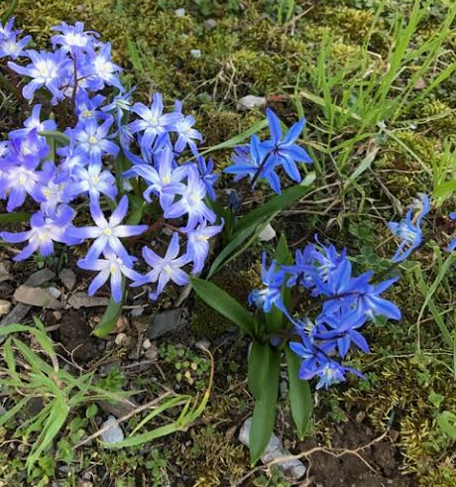
Here’s the amazing thing- we can be like those violets or other flowers popping up in the lawn when we live with Jesus. We, who are very ordinary people can live beautifully no matter our circumstances or the hidden challenges we face because Jesus offers us his beauty from the cross that takes away all that might keep us from thriving and blooming. He offers to help us as he lives in and through us whispering his love through the water of the Spirit and pouring his fertilizing grace on us so that we might share our blooms for his glory today.

Rev. Mike Endicott, In His Footsteps

