What Does Your Lenten Discipline, Discipline?
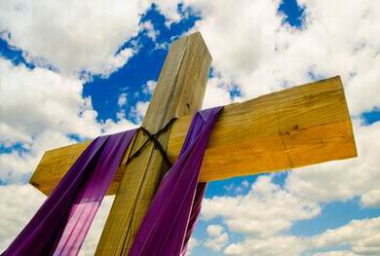
At our Ash Wednesday service this week the scripture from Matthew 6 “Beware of practicing your piety before other…” reminded us that whatever acts of piety or discipline we perform – to do them to be praised by anyone negated the real essence of living our life with and for God. That is not to say that these wonderful activities aren’t helpful, hopeful or beneficial. Just that, personally our motivations may not be in line with living humbly with and for God.
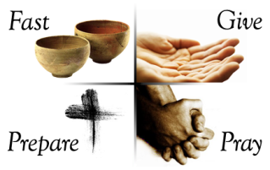
In keeping with this passage I have given a good deal of thought to what I should fast from in my life, who or what I will give alms to and/or pray for. I won’t give away all my decisions because then I could be in a way seeking your approval or making myself feel proud. Instead I’ll offer one example of what beginning a Lenten discipline, disciplines in me.
Why fast? What should we fast from? Food? Ideas? Actions? These are questions I considered especially since I have a somewhat limited diet and have trouble keeping weight on. Therefore the traditional fast from food seemed an unlikely candidate for my Lenten discipline. I wanted to choose a fast that I might be able to continue after the season of Lent. Lent, after all is a time to try out disciplines or acts of piety that adjust and enhance our life with God.
In years past I added daily Bible reading using the Lectionary and other aspects of meditation which now are part of my daily devotional discipline. With that in mind, I wondered about what in my life did I need to stop, since fasting means to abstain. What thought processes weren’t getting me closer to God? That was a pretty easy question to answer- worry.
Jesus speaks directly about worry or anxiety in scripture. Luke 12:25-26 “And can any of you by worrying add a single hour to your span of life? If then you are not able to do so small a thing as that, why do you worry about the rest?” Even the Apostle Paul addresses worrying. Philippians 4:6-7 “Do not worry about anything, but in everything by prayer and supplication with thanksgiving let your requests be made known to God. And the peace of God, which surpasses all understanding, will guard your hearts and your minds in Christ Jesus.”
As I contemplated my tendency to worry I realized if I really looked deep down in to why I worry, it’s because sometimes I can’t control the outcome and I don’t trust God to be sufficient for with whatever I’m worrying about. After realizing this humbling realization, I have chosen to fast from worry these 40 days, 38 days left but who’s counting?
I then looked up some scripture references, two are listed above, to help me in the moments when I catch myself worrying. I realize when I call these scriptures to mind that all of me and my life is held in the Most Holy hands of God, the One who sent Jesus and who helps me daily remember whose I am and how to live humbly and joyfully. He puts a new and right spirit in me so I can rest and be relieved of worries.
As in all fasting this is a daily discipline. In keeping this fast, I must check my thoughts as well as my gut – to see if I am really at rest or have transferred my worry from my head to gut. It’s then that I remember Jesus’ other words. Matthew 11:28-30 "Come to me, all you that are weary and are carrying heavy burdens, and I will give you rest. Take my yoke upon you, and learn from me; for I am gentle and humble in heart, and you will find rest for your souls. For my yoke is easy, and my burden is light."
As I hear these words, I can begin to unwind myself from under my burden of worry and slip under Jesus’ yoke. I can let him shoulder my concerns and cares. I can rest in his kindness and comforting yoke knowing I don’t hold these concerns alone. Jesus offers me the assurance that he has conquered the grave and whatever it is I am worried about when I trust in him. He also reminds me that he has been given all the power in heaven and earth and certainly has the wisdom necessary to enlighten me.
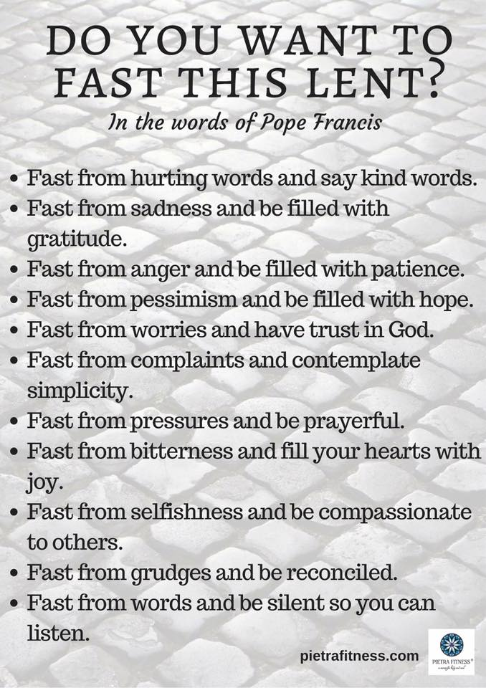
If you have not chosen a fast for Lent, let me offer this list for some new possibilities.
Blessings as we journey to Easter and grow our faith and faithfulness in God through and with Jesus along the way.

