Gerrardstown Good News!
March 28, 2017

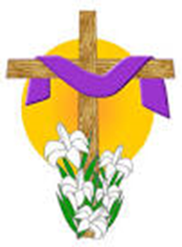
Children’s Easter Make & Take
Who: Children preschool through 5th grade.
When: Saturday, April 1st
Time: 10:00-11:30 AM
Where: Gerrardstown Presbyterian Church 372 Dominion Road Gerrardstown, WV
Come learn about the Easter story, make a spring bird house, and have a delicious springtime snack. All kids will leave with a bag full of their own projects and some extra fun goodies.
Call Becca Sturm at 304-280-8640 to reserve your spot today!

Rocks by Pastor Karen Greenawalt
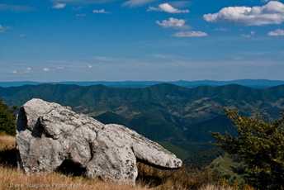
We live in rocky country here in WV. Rocks are easily seen peeking out of the ground or not so easily seen hidden where you’d like to start a foundation or dig a hole. They jut out of the hillsides and land making farming a challenge. But they are also used beautifully as building materials. Rocks are just part of the landscape and the price you pay to live in and near the mountains here.
What is most interesting about the rocks we see is that there are many varieties. As I started researching I found that West Virginia, particularly the Eastern Panhandle, has a long history of rocks! These rocks developed millions of years ago when the land masses were forming and colliding. Some of the many types of rocks that lurk under the surface of the mountains and the hillsides were formed during the Paleozoic – Ordovician period (444-488 mil. yrs. ago) including Limestone, dolomite, sandstone, shale, and metabentonite. Limestone (particularly low silica), building stone, clayshale. I certainly did not know that our rock formations here were so varied and interesting! I just knew they were hard and made it difficult to dig a hole for a grave or place signs in the ground resulting in the need for heavy drilling or digging equipment.
Rocks also figure quite prominently in the Bible. The area around Palestine is also very rocky and mountainous. It was common to use caves for burial sites and rocks as the seal. Stones were often used to build altars, the temple and cover wells in the ground.
At first glance rocks seem lifeless, not life- giving in any way. They just seem to an obstruction. Yet these same rocks that trip us up are good for building walls, a fence or a house.
When the Israelites left Egypt abruptly crossing the Red Sea they found themselves in a barren wilderness. Rocks were plentiful but water was not. At one particular stopping point Rephidim, the people began to complain that they would die of thirst for there was no water nearby. Moses became afraid that the people would pick up the rocks and stone him so he cried out to God. God told Moses to take his staff. ”I will be standing there in front of you on the rock at Horeb. Strike the rock, and water will come out of it, so that the people may drink." (Exod. 17:6 NRS). He did and the water flowed from the rock. All could assuage their thirst. Moses renamed the place Massah and Meribah because the people quarreled and tested the Lord. In other places in the OT David, who had spent much of his youth among the hills and plains keeping sheep, gives God the moniker of ‘rock’ NRS 2 Samuel 22:3,47 ‘My God, my rock, in whom I take refuge, my shield and the horn of my salvation, my stronghold and my refuge, my savior; you save me from violence…. The LORD lives! Blessed be my rock, and exalted be my God, the rock of my salvation.” And the Psalms, many written by David, remind us of what a powerful image the rocks were for David as he spoke and sang to God. Psalm 62:5-8 is a good example: “For God alone my soul waits in silence, for my hope is from him. He alone is my rock and my salvation, my fortress; I shall not be shaken. On God rests my deliverance and my honor; my mighty rock, my refuge is in God. Trust in him at all times, O people; pour out your heart before him; God is a refuge for us.”
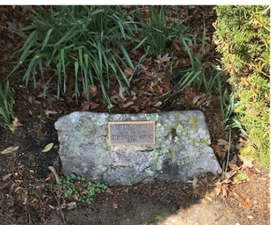
Centuries later Jesus would give his disciple Simon the name Cephas, which means stone, Peter in Greek. Jesus referred to those who listened to him and did what he said as those who built their house on the rock and although floods and river might rise and push against the house; their house would and. Later Jesus would talk about stones again when he quoted Psalm 118 explaining this verse prophesied about him “The stone that the builders rejected has become the chief cornerstone. This is the LORD's doing; it is marvelous in our eyes.” (Ps. 118:22-23 NRS). Jesus added, ‘Therefore I tell you, the kingdom of God will be taken away from you and given to a people that produces the fruits of the kingdom. The one who falls on this stone will be broken to pieces; and it will crush anyone on whom it falls." (Matt. 21:43-44 NRS).
Peter having lived with his name meaning rock or stone and living with the Stone that the builders rejected who became the Cornerstone adds these thoughts to us who encounter Jesus today in 1 Pet. 2:4-6 NRS: “Come to him, a living stone, though rejected by mortals yet chosen and precious in God's sight, and like living stones, let yourselves be built into a spiritual house, to be a holy priesthood, to offer spiritual sacrifices acceptable to God through Jesus Christ. For it stands in scripture: "See, I am laying in Zion a stone, a cornerstone chosen and precious; and whoever believes in him will not be put to shame."
To you then who believe, he is precious; but for those who do not believe, ‘the stone that the builders rejected has become the very head of the corner, and a stone that makes them stumble, and a rock that makes them fall.’(1 Peter 2:7-8)
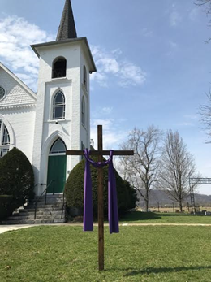
As we continue through the end of Lent and prepare to walk with Jesus to the cross, let us remember that we can be built into a spiritual house, a holy priesthood which is our spiritual sacrifice, acceptable to God through Jesus the rejected stone, but who is mightily precious in God’s sight. We can’t do this but we can submit ourselves to God in Christ who can bring life to our rock-like hearts and make us holy and living stones in the spiritual house of the Lord.
As you see the rocks this week, remember that Jesus wants to make you into a living rock in his spiritual house - the Church. For in him we will never be put to shame!
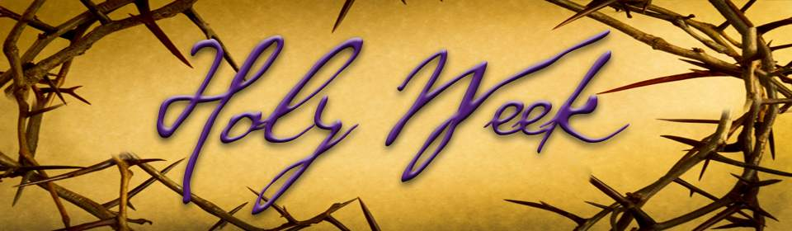
Sunday April 9 – Palm Sunday 11am Celebrate Jesus Triumphal Ride into Jerusalem with Palms
Thursday April 13- Maundy Thursday Service 7pm with Communion-in the Sanctuary
Good Friday April 14 – Prayer Vigil- 6am-6pm in the Sanctuary- all ages are welcome – there will be devotional materials and stations for prayer.
Easter Sunday April 16 – Come celebrate the resurrection of Jesus beginning with fellowship time at 10am on the front lawn, Worship at 11am and a Resurrection Easter Egg Hunt during Children’s Church

New Associate General Presbyter
for Shenandoah Presbytery
There was a Special Presbytery Meeting held on March 4th to examine the candidate, The Rev. Nancy Meehan Yao for Associate General Presbyter. Her examination was sustained and we were glad to welcome and install The Rev. Nancy Meehan Yao to be our new Associate General Presbyter.
Nancy grew up in upstate New York in a Roman Catholic and Presbyterian home. She graduated from Russell Sage College and did post graduate work at NY University. She met her future husband during college while they were both singing in the choir. They married and are proud parents of two sons John and James.

The Yao family moved to St. Augustine and were active in the Memorial Presbyterian Church. During this time Nancy and her husband Jim began to discern their call to ministry. They attended and graduated from Columbia Seminary.

Nancy and Jim have served numerous churches both together and separately. We look forward to getting to know Nancy better and the ministry she will bring to Shenandoah Presbytery.

GPC Session Highlights for March 2107
At the March Session Meeting we again hosted Adam Stewart, our financial advisor for updates on the church’s investments. He will come back with suggestions next month based on discussion.
We are waiting on bids from two contractors for the handicapped bathroom. Construction will hopefully begin in the next couple months.
Charles Linton and Dwayne from Mt. Pleasant Chapel are working on a project to honor first responders in coordination with other churches and local businesses in this area. Stay tuned for more information coming soon.
We have updated our insurance policy with Bitner Henry Insurance and signage was approved to promote special events at the church.
A discussion was held on the response to the letter sent to those who haven’t been active at GPC. Pastor Greenawalt offered a shepherding plan to help us stay in better contact with all members and friends of the church.
The possibility of offering Before and After School Care at GPC is being researched. More information will be forthcoming.

To read the Newsletter online go to our webpage gerrardstownpc.com
You can also find us on Facebook- Gerrardstown Presbyterian Church Life
“The Season of Hope”
Shenandoah Presbyterian Women
Annual Spring Gathering
April 8, 2017
Massanetta Springs Conference Center
Harrisonburg, VA

Please be in prayer for the following friends, members of GPC: Rev. Bill and Janet Starr and their son-in-law Matthew Baynes and his family, Donald Richter, Regis and Betty Knauff, Eileen Pettersen, Abby Bender, Roger Campbell, Jay, Connie, Scottie, Jean, Cindy Butts, Frank Leonard, Gerrit Myers, Mike Jessup, Allen Martin, Curtis Butts, Janet Sherrard, Dick LeDane, Amelia Sturm, Grace Weekley, Kenneth Corbin, Samantha Oester, Jim Butts, Kenda Butts, Leonard McDaniel, Linda Stillwell, Peter Housel, the victims of flooding, forest fires, and violence, First Presbyterian Shepherdstown as they being the search for a new pastor, our community and elected leadership, the church world wide and all the members, friends and pastor of GPC.
“May today there be peace within. May you trust God that you are exactly where you are meant to be. May you not forget the infinite possibilities that are born of faith. May you use those gifts that you have received, and pass on the love that has been given to you. May you be content knowing you are a child of God. Let this presence settle into your bones, and allow your soul the freedom to sing, dance, praise and love. It is there for each and every one of us.”… Teresa of Avila

