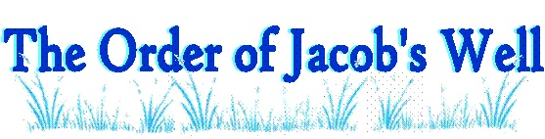
In His Footsteps
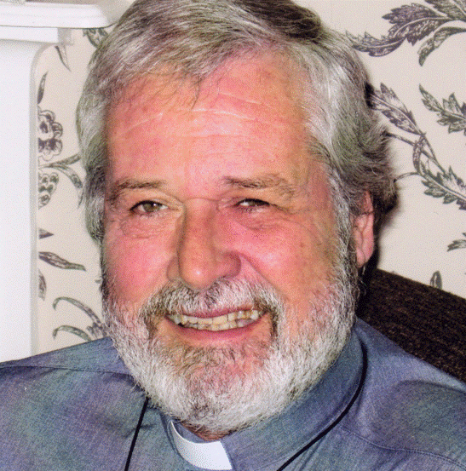
A video course on the Kingdom of God and Healing.

This video course is taught by Rev. Mike Endicott, an Anglican pastor and Founder of The Order of Jacob’s Well, UK. Mike and many other elders scattered all over the world have studied the Kingdom of God and especially how it relates to healing. This video series is a culmination of of their learning up to this point. But the learning and growing in the grace of the Kingdom continues even now.
Place: Gerrardstown Presbyterian Church Hall
372 Dominion Rd. Gerrardstown, WV 25420
Time: Tuesdays beginning March 7th at 10am-1130am or 7pm-8:30pm. This course takes approximately 12 weeks to complete.
Facilitator: Rev. Karen Greenawalt, pastor Gerrardstown Presbyterian Church
Cost: $12 for a book
For more information or to register please email gerrardstpc@gmail.com or call the Church Office at 304-229-2316
For more information about the Order of Jacob’s Well and Rev. Mike Endicott visit http://www.jacobswell.org.uk/ or http://www.simplyhealing.org/wordpress/

