Gerrardstown Good News!
March 1, 2017
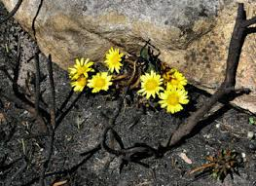
Lent Means Ashes and Flowers
By Pastor Karen Greenawalt

When you look up the meaning of the word ‘lent’ you find that it means spring. Hence we think flowers, rain and warmth. But we don’t usually proclaim “It’s Lent!” when we are discussing seasons. We do however talk about “It’s Lent” from a liturgical calendar point of view.
In the church calendar the 40 days before Easter, not counting Sundays, is called Lent. It has traditionally been a time of preparation- including fasting, study and prayer as we grow in our repentance, love and faithfulness. What once was mostly a Catholic observance is now followed by many denominations including Presbyterians!
Why ashes? What do ashes have to with Lent? In the OT scriptures we read “sack cloth and ashes” Esther 4:3 or “I despise myself and repent in dust and ashes.” The Jews used ashes as part of their mourning rituals and when they would fast as part of the act of repentance. But if we keep reading in the OT we find this passage from Isaiah 58:5-7 “Is such the fast that I choose, a day to humble oneself? Is it to bow down the head like a bulrush, and to lie in sackcloth and ashes? Will you call this a fast, a day acceptable to the LORD? Is not this the fast that I choose: to loose the bonds of injustice, to undo the thongs of the yoke, to let the oppressed go free, and to break every yoke? Is it not to share your bread with the hungry, and bring the homeless poor into your house; when you see the naked, to cover them, and not to hide yourself from your own kin?”
God seems to have a different opinion of what we should do when we fast or humble ourselves.
Ashes remind us that we are but dust and to dust we shall return. And we do need to repent – that is – turn from our sin. As God told the Israelites much more is required of us than to just lie around fasting in sackcloth and ashes!
Matthew 6:17-18 tells us what Jesus said about fasting: “But when you fast, put oil on your head and wash your face, so that your fasting may be seen not by others but by your Father who is in secret; and your Father who sees in secret will reward you.”
What kind of Lent will we undertake this year? One way to begin Lent is to come to the Combined Ash Wed. Service, Wed. March 1st at 6:30pm at Tuscarora Presbyterian Church. GPC and other area Presbyterian churches in our area will be participating. In the service we will receive ashes but not sackcloth! We will have the opportunity to come forward to receive the ashes on our foreheads as a reminder of our own mortality. We will sing and prayerfully consider our need for repentance. Then we will have the opportunity to receive an anointing of oil on our hands to prepare us for the work of service as part of our Lenten preparation for Easter.
What kind of service is God calling us to be involved in during Lent? Let us to be in prayer with our eyes and ears open for what ways we can help bring justice, share bread with the hungry or help the homeless find a home to live in. How can we get clothes to those in need and be available to those in need as the scripture in Isaiah 58 suggests?
There are plenty of ways to help in our local area. Each of these affords us a way to fast from thinking only of ourselves and to care for those who are in need. See page 3 of this newsletter for details.
Wed. March 1st Ash Wed. Service at 6:30pm at Tuscarora Presbyterian Church
Sun. March. 5 Coffee and Conversations 9:45-1045am on the Gospel of John – ch. 7. Children’s Sunday School - downstairs
Worship at 11am. Sermon Series on Kingdom Life: The Beatitudes continues all month, Children’s church after the Children’s Message.
Sun. March 12 Coffee and Conversations 9:45-1045am on the Gospel of John – ch. 8. Children’s Sunday School - downstairs
Worship at 11am. Sermon Series on Kingdom Life: The Beatitudes continues all month, Children’s church after the Children’s Message
Sun. March 19 Coffee and Conversations 9:45-1045am on the Gospel of John – ch.9. Children’s Sunday School – downstairs.
Worship at 11am. Sermon Series on Kingdom Life: The Beatitudes continues all month, Children’s church after the Children’s Message We will share the Sacrament of Communion, followed by the Asian Themed Fellowship Meal. Everyone is welcome.
Sun. Mar. 26 - Coffee and Conversations 9:45-1045am on the Gospel of John – ch. 10. Children’s Sunday School - downstairs
Worship at 11am Kingdom Life: The Beatitudes with Children’s church after the Children’s Message.
Tues. Mar. 28- Free Community Dinner from 4:30pm-6:30pm in the Hall. Help is needed to set-up and clean-up. Please contact Bev Hughes for more information 301-876-3093 or bhugh@frontiernet.net

The Season of Lent Begins!
March 1 – Combined Ash Wednesday Service at 6:30pm at Tuscarora Presbyterian Church 8854 Tuscarora Pike, Martinsburg, WV 25403 Pastor Karen will be helping to lead this service.
During Lent we will take on a special mission emphasis of supplying the items needed by Shenandoah Women’s Shelter. This Shelter is a safe house for anyone who is experiencing domestic violence. It is a safe place to turn for help or to escape. Their Hotline is 304-263-8292. Please share this number is you know someone who needs it.
Please bring items from this list below throughout Lent and then we will deliver these to the shelter.
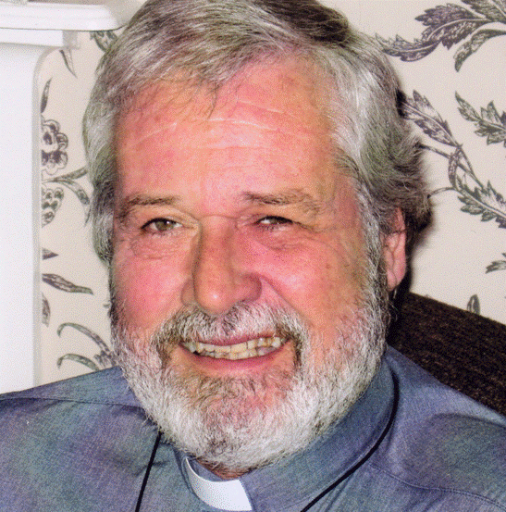
A new study is being offered! Join us for In His Footsteps
This video course is taught by the Rev. Mike Endicott, an Anglican pastor and Founder of The Order of Jacob’s Well, UK. The subject of the course is the Kingdom of God and Healing.
Place: Gerrardstown Presbyterian Church Hall
Date: Tuesdays beginning March 7th
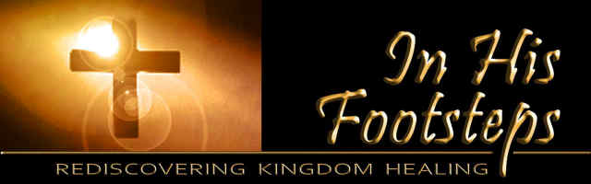
Times: Either 10am-1130am or 7pm-8:30pm. (please sign up for the time you prefer)
Duration: The course takes 12 weeks to complete
Facilitator: Rev. Karen Greenawalt
Cost: $12 for a book
Session Highlights
In our February Session meeting we discussed the upcoming events many of which are listed on the calendar in this newsletter. Jessica Grubb was restored to the membership of GPC by reaffirmation of faith. Progress has been slow on the installation of the new handicap bathroom for lack of a carpenter.
We remember these friends and family to God in Prayer
Roger Campbell, Cindy Butts, Thurman Brady, Darrell, Jay, Frank Leonard, Gerrit Myers, Mike Jessup, Allen Martin, Curtis Butts, Janet Sherrard, Dick LeDane, Amelia Sturm, Grace Weekley, Kenneth Corbin, Samantha Oester, Jim Butts, Kenda Butts, Leonard McDaniel, Linda Stillwell, Peter Housel, the victims of flooding, forest fires, and violence, our community, elected leadership and all the members, friends and pastor of GPC.
Missions Who Need Our Help:
Rescue Mission in Martinsburg –Laundry and Cleaning Supplies in March
Back Pack Children – plastic grocery bags
Monetary Donations to CCAP
Session Members for 2017
Harriet Kopp – clerk
Glen Sherrard
Charles Linton
Stephen Zurenda
Grace Weekley

If you have a prayer request or are in need of help please call the church office 304-229-2316; email the church office at gerrardstpc@gmail.com or call Pastor Karen on her cell phone 407-619-2821.
Like us on Facebook! https://www.facebook.com/Gerrardstown-Presbyterian-Church-Life-1741871242694671/?ref=aymt_homepage_panel
Check Out Our Website
http://gerrardstownpc.com/
Sunday’s Sermon and Prayer can be found on our Website, Facebook or at our Youtube site: https://www.youtube.com/channel/UCLfSklx6M0fTP67LLAijmuw

