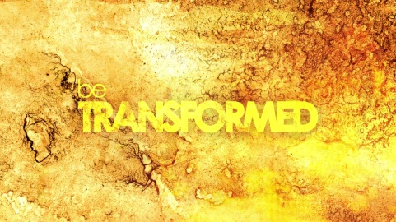
Be Transformed
Have you seen the videos where a young soldier comes home early from being deployed overseas to surprise his mom with the video camera rolling? The transformation of the person being surprised is amazing to watch. Her face changes from shock to the dawn of recognition to surprise with tears of joy and finally laughter, more tears and fierce hugs. Someone who was just going about life is suddenly full of joy! It can happen – even to ordinary people.
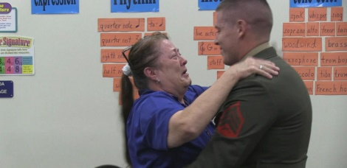
What transforms these people who are surprised? Their great love and longing overflows in joy and tears. How can we be transformed on a daily basis? How do we get past and get through the hurts, frustrations, and dead ends we meet daily? Instead of seeing those we yearn to see – often we are challenged by those who cause us pain or heart ache. We live with aches and pains in our bodies, minds or spirits.
In a surprising ways, Jesus went about transforming people’s lives. Scripture tells us how he blessed the children and lifted up the woman bent over and spoke release to the man bound up for 38 years. He recognized people no matter how they looked or what they’d been through, even the woman caught in adultery or the woman at the well. Jesus spent time with them and offered them transformation by giving them a new way to see Life.
Jesus offers us transformation too when we meet with him. He won’t videotape it or play it back on Facebook but when we yearn for him, he comes to us as well, just like he did those in scripture. His presence with us is comforting because Jesus is here whenever we need him! We don’t have to wait until we die or a special occasion. Today, when you are sad, unhappy, hurt or feel overwhelmed; I offer to you Jesus. His love reaches us not matter if we’ve caused our own grief and hurt or someone else did. His word to us is full of hope, peace, forgiveness and healing. When we take him into ourselves we can be transformed by him. I am thankful that nothing is too hard for Jesus for he overcame death on a cross to set us free to be transformed, now through eternity.
This Sunday Feb. 26 at 11am we will hear more about transformation in the Kingdom of God. Come join us or tune in on our website https://www.gerrardstownpc.com or our YouTube channel https://www.youtube.com/channel/UCLfSklx6M0fTP67LLAijmuw later in the day.
Other Scripture passages you might find helpful:
NRSV Matthew 11:28-30 28 "Come to me, all you that are weary and are carrying heavy burdens, and I will give you rest. 29 Take my yoke upon you, and learn from me; for I am gentle and humble in heart, and you will find rest for your souls. 30 For my yoke is easy, and my burden is light."
Matthew 18:21-22 21 Then Peter came and said to him, "Lord, if another member of the church sins against me, how often should I forgive? As many as seven times?" 22 Jesus said to him, "Not seven times, but, I tell you, seventy-seven times.
NRSV Matthew 28:20 - Mark 1:1 And remember, I am with you always, to the end of the age."
NRSV John 14:27 7 Peace I leave with you; my peace I give to you. I do not give to you as the world gives. Do not let your hearts be troubled, and do not let them be afraid.
NRSV Romans 8:31-39 31 What then are we to say about these things? If God is for us, who is against us? 32 He who did not withhold his own Son, but gave him up for all of us, will he not with him also give us everything else? 33 Who will bring any charge against God's elect? It is God who justifies. 34 Who is to condemn? It is Christ Jesus, who died, yes, who was raised, who is at the right hand of God, who indeed intercedes for us. 35 Who will separate us from the love of Christ? Will hardship, or distress, or persecution, or famine, or nakedness, or peril, or sword? 36 As it is written, "For your sake we are being killed all day long; we are accounted as sheep to be slaughtered." 37 No, in all these things we are more than conquerors through him who loved us. 38 For I am convinced that neither death, nor life, nor angels, nor rulers, nor things present, nor things to come, nor powers, 39 nor height, nor depth, nor anything else in all creation, will be able to separate us from the love of God in Christ Jesus our Lord.

