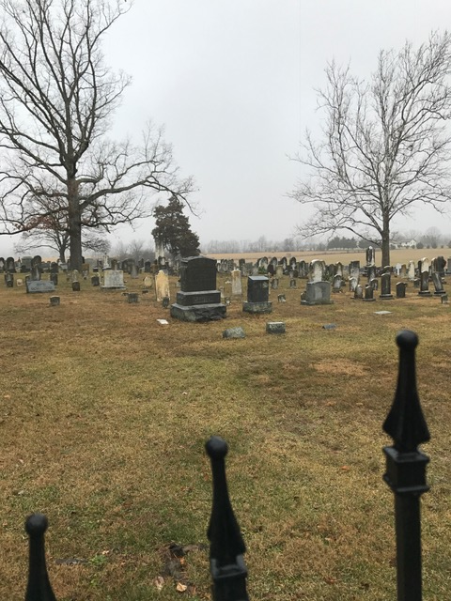
Seeing Isn’t Believing
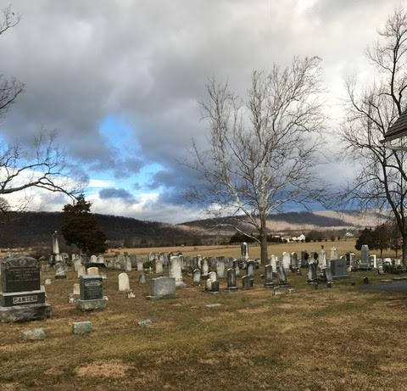
The first time we came to visit Gerrardstown, everyone told us there was this range of mountains behind the church and that we could see North Mountain if we looked. Just like the picture to the left - we kept looking but could not see it! We joked that maybe there wasn’t a mountain at all. However, the day we were leaving, we drove by the church one last time. The fog had lifted and we could see the mountain!
As I walked to work earlier this week I was greeted by that same wall of fog as I looked towards the mountain. Of course, now I know that mountain is there because I’ve seen it and I know that today I simply cannot see it from my vantage point. These questions of seeing and believing make me wonder what comes first the seeing or the believing? In the case of the mountain, we believed what we had been told. There must be a mountain back there somewhere - so we made one last trip to “see” what we had believed.
We may feel the same way about God sometimes. We have been told ‘God is here’. ‘God loves you.’ ‘God is at work in this world.’ But when we look around it can be difficult to ‘see’ from our vantage point. Our circumstances may not feel very loving. Our prayers seem to just bounce back at us, not producing any changes. If we can’t ‘see’ the evidence we are looking for we may decide God is not loving, here or at work and therefore we feel as if we are struggling alone.
How do we combat the need to see first and then believe syndrome of faith? It can be difficult and leaves some people with a cynical view of this world and/or especially about God.
Thankfully Jesus talked with people about this very topic, a lot. There was a father who came to beg Jesus to come heal his son. Jesus responded “Unless you see signs and wonders you will not believe.” He pleaded again with Jesus. Instead of going with him, Jesus said “Go, your son will live.”(John 4:47) When Jesus was talking with Nicodemus he said to him, “If I told you about earthly things and you do not believe, how can you believe if I tell you about heavenly things?” (John 3:12) Later he told the people who came back to find him after eating the bread when he fed the 5,000 “But I said to you that you have seen me and yet do not believe.” (John 6:36) Even his own disciples he said, “But among you there are some who do not believe.”(John 6:64)
We all have moments when we doubt just like when we looked at the fog and we were sure we couldn’t see the mountain. Yet it was there all the time. God is too! I think back now to that foggy mountain view and realized we did “see” the mountain – oh not from a distance but by driving over it and around it as we toured the area. We went closer and sure enough, there was a mountain even though from a distance the clouds blocked our view! I think God, at times, is somewhat like that mountain. We may not be able to see God from our vantage point looking through our circumstances. Instead we must get closer and look. How do we do this? Jesus said, ‘if you’ve seen me, you’ve seen the Father’. That’s my rather loose translation of his words found in John 14:7-9. If we “look” at Jesus in scripture, we gain a much clearer view of God and how God loves, works and is with us.
But the trouble comes when some read Jesus and wonder if God was so loving and at work in Jesus then why did Jesus die on the cross. That doesn’t seem very loving nor does it look like God was with Jesus at all. But when we look even closer we see that the love of the Father for all his people was shared by Jesus- for they are one. And the pain experienced by God when God’s people did not love God, did not follow God’s will to love and serve each other and did not love or believe that Jesus was the Messiah, was shared by Jesus. It is what brought Jesus to the cross. God’s deep love for Jesus and all of us, helped Jesus decide to be not only the Messiah, Prophet and Priest but also the Lamb of God slain on a cross. Yet death could not overcome the Love that through death defeated all sin, hate, disease, pain, hopelessness and was Resurrected. What great love this is! Jesus showed us the love of God is indeed stronger than death and anything else that seeks to destroy us. (Check out Rom. 8:31-39 for more on that topic). The Kingdom of God is a different kind of kingdom with a King who would die as servant and lamb and then was raised to be King for eternity.
The closer we walk with Jesus, the more we “see” God in an amazingly clearer light. No matter the fog of our circumstances, Jesus offers us overcoming love and grace that is real in this the Kingdom of God.
We will be learning more about this Kingdom these next several weeks as I begin a new sermon series called Kingdom Life take from the Gospel of Matthew and the Sermon on the Mount. I hope you will join us – it begins this Sunday, January 22, 2017.

