The Un-Mannequin Challenge
I’m sure you’ve heard about, watched it or will be watching one if you are anywhere near social media, the Mannequin Challenge. Its genesis was a high school class room. “A teen, Jasmine Cavins, a junior at Edward H. White High School in Jacksonville, Florida” was the creator of this viral video craze. “The Mannequin Challenge was unwittingly born when ‘One day my friend walked to the front of the class and just stood there, so me and my friend joined her and we started doing crazy poses, so my friend was like, ‘We can make this challenge,’ Jasmine told The Post. Jasmine, 16, posted the video to her Twitter account about three weeks ago, and soon other classes and nearby high schools started making their own.” From there celebrities, sports teams, bands, churches and even my daughter’s division of Florida Hospital Revenue Integrity have gotten into the Mannequin Challenge act.
I must confess that I thought it would be fun for our small congregation at Gerrardstown Presbyterian to ‘get in on the act’ too. But the more I thought about it and yes, prayed about it, I felt that the Mannequin Challenge is what church has been doing for hundreds of years. Posing as Christians within our walls but not really moving out of the church and going where Jesus wants us to go. It is fairly easy to stop what you’re doing and pose – especially if you aren’t moving much to begin with!
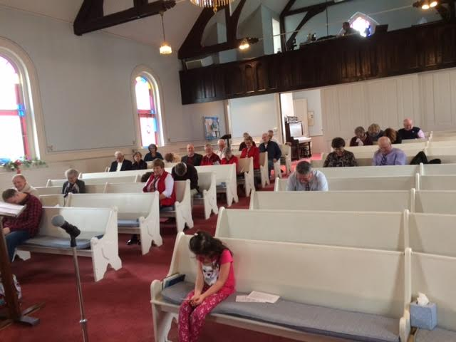
Yesterday the sermon topic was the Branch from Isaiah 11. From the stump of Jesse came the Branch. Stumps are pretty good at doing the Mannequin Challenge for years, centuries even! But the stump of Jesse, although it may have appeared dead, brought forth a Righteous Branch full of grace and truth – we know him as Jesus.
During our children’s message yesterday, our youngest participant in worship challenged the congregation to a stump challenge. Could they be stumps? The picture shows how well they complied! No one moved!
But a greater challenge is, can we grow again? With dwindling numbers and a rather tainted image, can we the church reach out with our hands and our hearts and break the image of a dead stump or mannequin we have held for much too long?
So I offer this challenge to our congregation and to all church congregations to not stand still but to move out, speak out, look out for those in need, for those who you can invite along, for those you can offer a word of encouragement and kindness. Our world needs more kindness and much grace right now. Be less stump, more branch. Be less mannequin and more movable and creative in how you challenge the status quo with love. Bring the grace and love we enjoy in Jesus out of church to those who may only see the church as a mannequin still and silent, closed to and fearful of the world around them. I imagine a greater future with the church being the embodiment of the Branch that came with grace and truth, with forgiveness and welcome to all. The biggest challenge is letting Jesus change us and all who dwell here in order for the word-picture Isaiah painted to come alive as the wolf and lamb, leopard and goat, calf and lion live together peacefully as the little child leads them. Not just a frozen moment, but a place where there is no destruction or hurt in all of God’s world.

http://nypost.com/2016/11/16/why-simple-videos-like-the-mannequin-challenge-go-viral/
Ibid.

