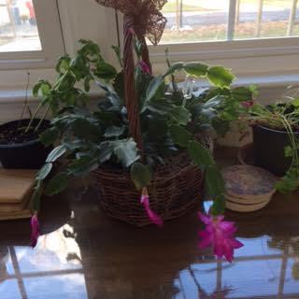
How Can You Tell It’s Christmas?
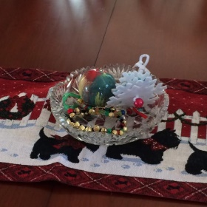
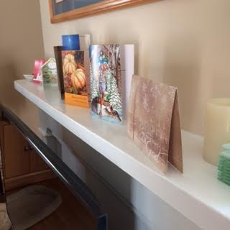
There are 5 blooms on our Christmas cactus that has been blooming since Thanksgiving. Is this how you tell it’s Christmas? The rest of the house is rather bare except for the decorative dog hair- golden in color -blooming all over the place, a few Christmas cards on the mantel, a well-worn poinsettia patterned kitchen towel and mix matched hot pan holders hang from above the sink, a Scottie winter table runner on the dining room table and a few newly made ornaments in a cut glass dish in the center. Is this how you tell it’s Christmas?
Christmas this year came at an inconvenient time. Our third daughter is graduating from UCF in Orlando, Florida nine days before Christmas. Our house, which has yet to sell in Florida, needs some tender loving fix up by my husband and son just two weeks before Christmas.
So how does one know that it is Christmas when all the things one normally would do for Christmas haven’t been or won’t be done this year because there just wasn’t time to put it all up, fix up a house, attend graduation and buy gifts for those we love?
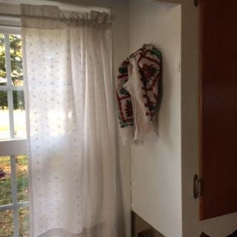
In the Wall Street Journal I read an article by Louisa Shaflah. Louisa says she knows it’s Christmas when she heats up her favorite traditional khoresh-e-kadu in the oven on Christmas day. As she smells the mingling scents of cinnamon and pumpkin wafting through her house- that’s how she knows it’s Christmas!
‘How do I know it is Christmas?’ I pondered as I ate leftovers at my kitchen table, realizing there was very little in my house to announce Christ’s birth this year. Is this how we know? Is it because we make sure every corner of our homes, offices and churches are filled with trees, ornaments, poinsettias and purple, red and green? Is it the Christmas covers of our bulletins or the blow up Christmas scenes around our houses, with shiny lights and music proclaiming in not-so-subtle ways that this time of year is different?
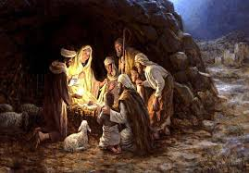
How did Mary and Joseph know that there was Christmas that first year, that first night in the cave-barn where they stayed? There was no doubt pain or at very least discomfort from a long trip, then more pain and discomfort as a new life was born in David’s town, a long way from Nazareth. No Christmas trees or carols played, no cards were sent or cookies baked. Was it the excited Shepherds coming unexpectedly to tell about angel sightings? Is that how they knew?
They knew and we can know too amid all the hoopla, even the hoola hoop of the Chipmunks’ Christmas song, amid the yummy foods and smells, the family and friends gathered together, amid stark Advent songs followed by festive Christmas carols sung by choir and congregation with candles purple, pink and white as we sense something important, no, Someone important who takes our attention from all the rest. God is present – even in my kitchen with little to show for Christmas- God comes quietly in where hearts make ready for his Son, Jesus. There may be pain and discomfort, as we try to make room for him in our busy lives, when our tight schedules center on everything else. And yet he waits, patiently, for us to let him make a place in us for him, Christ our Lord. For only in him will we find the real Christmas Spirit – the Holy Spirit of love and holiness experienced in the fruit of joy, peace, kindness and generosity that Jesus brings in our hearts and lives. These are the true decorations of Christmas that offer us what is missing in our lives and will decorate our heart the whole year through.
From our house to yours, the love and blessings of Jesus be yours at Christmas and the whole year through.

Wall Street Journal Saturday/Sunday Weekend Edition 12.10.16

