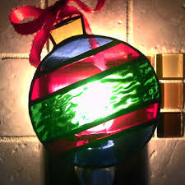
Ornament Night
People of all ages are invited to come for Ornament Night, December 3rd from 5-7pm at Gerrardstown Presbyterian Church Hall. There will be creative ornaments to make and take as well as cookies, hot cocoa and coffee. This event is free. Come and Join in the fun!

