February 2016 Newsletter
Gerrardstown Presbyterian Church
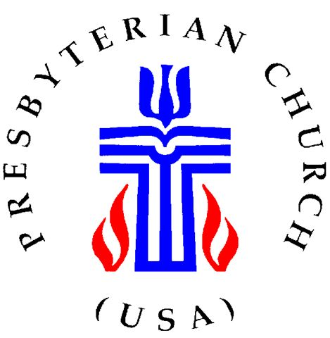

V Vision Statement
Gerrardstown Presbyterian Church embraces the challenges Jesus laid out for us as stated in Matthew 25: v35-36, 40. As a Christian community, we honor and praise the Living God and His Son, Jesus Christ through our worship, our warm and open fellowship, our bible studies, our missional initiatives, our membership growth through children and young adults and our generosity to those in need.
Matthew 25. V35 - 36, 40
For I was hungry and you gave me food, I was thirsty and you gave me something to drink, I was a stranger and you welcomed me, I was naked, and you gave me clothing, I was sick and you took care of me, I was in prison and you visited me…..and the King will answer them, ""Truly I tell you, just as you did it to one of the least of these who are members of my family, you did it to me."
Elders
Stephen Zurenda
Joe Sturm, Treasurer
Grace Weekley
Charles Linton
Judith Becker, Clerk
Contact Info
Church: 304-229-2316
Pastor: 407-619-2821
http://gerrardstownpc.com/
gerrardstpc@gmail.com

A small Church with a big heart and a rich heritage
PO Box 135 Gerrardstown, WV 25420
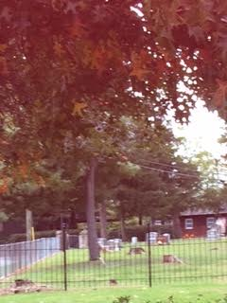
A Note from Pastor Karen
Seasons of change….
I feel the nip in the air in the early morning, the leaves are beginning to drop and the sun is not getting up nearly as early as it was. It must be Fall, which means our first summer together is over.
Much has been going on during this period of time. Our online presence is even stronger with a new website http://gerrardstownpc.com/ and a new Facebook page called Gerrardstown Presbyterian Church Life. The order of worship has been updated, speakers have floated to the front of the sanctuary, a new shiny black mailbox awaits cards and letters arriving at the church address, loving hands cleaned, painted and decorated several of the classrooms and the hallway in the basement. Make and Take was full of apple fun for the children last month, Coffee and Conversation can be had just before worship each Sunday morning in the Lecture room and Community Dinners have enjoyed great fellowship and outreach each month with numbers tipping over 100 for two of those months. Saxophones joined us one week in worship as did my husband Tom with guitar, me singing and Bev Hughes on the organ. Fellowship dinners are still after worship on the third Sunday each month. This past Sunday October 2nd we celebrated World Communion as we rejoiced in our oneness in Christ with those across the world as the family of God gathered at the bounteous table spread high with bread and cups of juice – remembering Christ’s death until he comes again. We culminate our connectedness this week by meeting at the Manse at various times for food and fellowship together.
As we move closer to November we are in the midst of planning Thanksgiving for others in need and the wonderful season of Advent and Christmas. The first Sunday in Advent begins November 27th –with Communion during Sunday worship at 11am followed by the next three Sundays of Advent and then our Candlelight Christmas Eve Communion service will be a family-friendly service Saturday December 24th at 4:OO pm. We look forward to seeing everyone –from the youngest to the eldest – joining together to give glory to God for God’s wondrous gift of Christ Jesus to this hurting and broken world.
I realize this congregation hasn’t had a full time pastor in residence for some time therefore I want you to know that I’m usually working Monday – Thursday from 9:30am – 1230 and from 1:30 pm-3:30pm in the Session House, although at times I may be out for pastoral obligations (Fridays are usually my day off). If you’d like to come visit, you can stop by anytime or call me at the church phone 304-229-2316 (leave a message if I don’t answer) or text/call me on my cell 407-619-2821 to set a time to visit. You can also email me: kgreenawalt1@gmail.com or the church email is gerrardstpc@gmail.com Please let me know if I can be praying for you or you would like prayer together. I pray daily for the needs of our congregation and would love to be able to pray specifically for yours. I would be happy to come pray if you are having surgery or just come and visit. As one pastor friend of mine told me, ‘it gives me a break from sermon and bulletin preparations!’ Plus I’d love to get to know all the members and friends of GPC.

Session Reports:
Clerk – GPC Nominating Committee is in process of nominating two candidates for the Session’s 2017-2019 Elder term. If you have an interest and would like to be considered, please contact Becca Sturm, Joe Sturm, Sandy Sherrard or Tracy Oester.

Treasurer – Upon advisement of GPC’s financial advisor, Session approved moving investment cash into a fund consisting of ‘socially responsible’ stocks. To date, the fund is outperforming most of the other funds in the portfolio and Session is considering shifting more assets into that fund. Cost of all renovations and repairs to church properties, including the Manse totaled $9,031.05. Some additional repair work to Church exterior and Session House will need to be done but that will be deferred until a later date. Three of the 4 Sunday School rooms have been repainted, either new carpeting or rugs have been installed as well as much needed storage and decorations all funded through generous donations. Thanks go out to all who donated money and who helped make these updates happen.

Worship –A newly formed Worship Committee met and has recommended the following enhancements or changes to our worship service:
- Communion service will now be scheduled for the 3rd Sunday of each month unless an exception requires a temporary change. This month we observed communion on World Communion Day. In November it will be celebrated on first Sunday of Advent, Nov. 27th, and we’ll have communion on Christmas Eve.
- The members who take collection and tithes will also serve as greeters before worship service.You do not have to be an elder to serve in this capacity. Please speak with Stephen Zurenda if you would like to volunteer with helping out.
- The worship team is looking for volunteers to be lay readers at our worship service. Please see either Stephen or Pastor Karen if you would like to help with this easy task.

Fellowship – There is still a need for a host/sponsor for the November Fellowship November 20th. The alternative might be to hold Fellowship at a local restaurant. Session would appreciate your feedback on this.

Membership – GPC welcomes back Fred Bauserman who has requested that his membership be reactivated. We are so glad to have Fred worshipping with us once again. If you know of anyone interested in exploring membership with us, please speak with Pastor Karen and she can take it from there.

Christion Education – Session has approved the purchase of bibles to give to our Sunday school children. And Tracy Oester informed us that she is very happy with the new Sunday School curriculum recently received. She reports that it very user friendly, has lots of activities for all ages and great bible lessons to make the learning meaningful. Thanks go to Tracy and Becca Sturm for heading up this initiative.

Outreach and Evangelism –
- Make and Take was restarted with eleven children attending. They all had a good time with the story time and activities which included making their own apple dumpling. Next month the activity will be a family game night and in November a chaperoned movie will be shown so parents can have a ‘date night’. More on these activities will occur on the church blog/website and on facebook.
- Community Dinners – on behalf of GPC, Bev Hughes has applied for a financial grant through Presbytery’s Lyle Moffett Grant offering. This would be to support our popular monthly free dinners. This outreach project has completed its 5th year serving our community and often counts over 100 meals served every 4th Tuesday.
- Banner Bees – this is an outreach project headed by Grace Weekly and Mary Campbell. It has a first goal of completing 100 of these charming small banners to cheer up and spread God’s love to children undergoing medical/health challenges. They have designated the first 100 to go to the patients of the hospital where our own Amelia Sturm has received treatments. Mary and Grace look to continuing this project so other children at other medical care facilities can also be blessed by these ‘Banner Bees”. They are looking for volunteers to help with the assembly of these fabric banners which only require a minimum of ironing on the precut pieces. Please see Mary or Grace if you can help them.
- Session approved buying an ad in The Journal to announce a contest “What Christmas Means to Me.” This will be for students in 7th grade through senior high school, will be judged and winners will receive a cash award.

Cemetery Report – John Oester: The cemetery information is now available on the church’s website: http://www.gerrardstownpc.com

Buildings and Grounds –
- Session has engaged a person to clean the church once a month and the hall on an as needed basis.
- The first floor handicapped accessible restroom will be built into the far corner of the Lecture Room. The plans are in the design phase and will undergo zoning approval before construction begins. Thanks go to Charles Linton. Joe Sturm and Tom Greenawalt for their involvement in this much needed addition to our facility.
- Watch for notices of our annual Fall Cleanup which will occur after the leaves have fallen. Again refer to our website for updates. “Many Hands Make Light Work”!
- A motion detection light is being placed at the parking light to keep the area safe and hopefully discourage the use of our property being used inappropriately.

Prayer List: Amelia Sturm, Grace Weekley, Leonard McDaniel, Willard Sharp, Mary Ann Brannon, Sharon Martz, Janet Sherrard, Dick Le Dane, Norma Westbrook, Kenneth Corbin, Samantha Oester, Jim Butts, Kenda Butts, , Linda Stillwell, Peter Housel, Wayne Doyle Jr.,Frank, Wanda and all those effected by the recent hurricane. If you know of anyone else who should be on our list, please contact Sandy Sherrard.

- Coming Events:
- Community Dinner – Fellowship Hall 4:30 – 6:30 – (Every last Tuesday of each month)
- Communion – First Sunday of Advent, Nov. 27, Christmas Eve, Jan. 8, 2017
- Family Game Night – October 22nd at the Hall
- Children’s movie night – Nov. 26
- Christmas Eve service 4 pm
- Outdoor Fall Cleanup – TBD
- Rescue Mission needs: October – laundry and cleaning supplies, November - , December -

