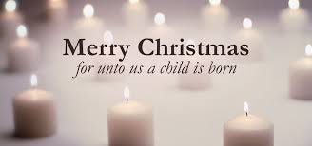
Merry Christmas! We hope you will join us on Christmas Day to celebrate the birth of Jesus! Worship for all ages begins at 11am

