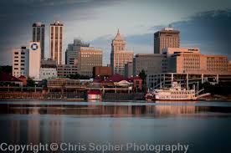
This One Was Born There
Everyone has a hometown, even if we aren’t always proud of it. Everyone was born somewhere. I was born in Peoria, IL. I have always felt it was a good place from which to come; a fine place to go back to visit on holidays and family visits. It was home because my parents lived there almost their entire married life. They were married there, had all of us kids there and continued to live on Isabel St. until their last days on earth. Where else would I call home?
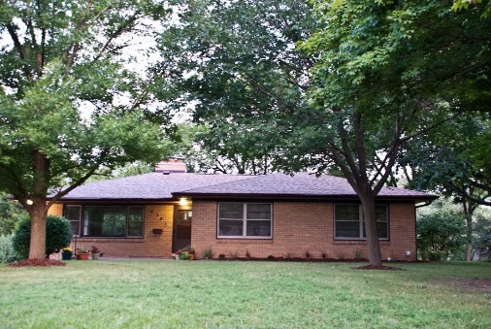
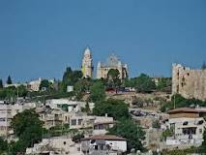
Going home in a Jewish context in Psalm 87 is Zion, Jerusalem to be specific. All through this Psalm the Psalmist refers to “this one was born there.” It seems that no matter where you may be, your home, your “birthplace” is Zion or Jerusalem. This spot on earth was very special because “the Lord loves the gates of Zion.” I don’t claim to know all that this Psalmist meant but as I read and re-read this Psalm I realized that Jerusalem was very holy because Jerusalem was loved and chosen by God. But more than a place – indeed the Psalmist seems to infer that God loved God’s people who dwelt in Zion or wherever they might be.
I realize that this is why the old house on Isabel Street was special to me. It was not only the place that my parents built, but it was where my parents and my siblings and I lived together, fought together, cried together and oh yes, laughed and laughed together. It was the place where for good or for bad, our parents disciplined, fed and clothed and loved us most of all. But when parents die, as ours did within 15 days of one another, what do you do? The ones who cherished us were gone. The place they once lived seemed totally desolate. A house is just a house without those who make it a home.
As I read the Psalm again I realized, God, more than Jerusalem, was truly “the home” of the Jews. Oh Jerusalem and the Temple were very, very special because God made that God’s dwelling place within the Holy of Holies. But when Jesus came, God revealed something quite remarkable –God decided not to limit who could call God home. No longer was it limited to those who lived in Zion or were called Jerusalem home wherever they lived. Jesus showed us that God now calls to each of us to come, make God our Home, to be re-born in waters of rebirth into God, as Jesus explained to the Pharisee Nicodemus in their late-night conversation described in the Gospel of John chapter three.
To find our beginnings again in God through Jesus gives us a chance to be re-start our lives. To be born in God is find the genesis of who we are. It was God who gave us life and gives life still. Where can we find another so constant, so welcoming? Who else can forgive us so completely or comfort us so entirely? Who else can confront and nudge us out of our complacency and focus our energies into what is most important? Who else loves with a love so steadfast and true that none other will ever come close? Who will never leave us nor forsake us, indeed God promises that not even death can separate us from God’s love in Jesus.
I am thankful for the words “This one was born there” because these are my words too. They describe not only my hometown Peoria, IL but also my forever home in God the Father, Jesus the Son and the Holy Spirit who also makes me their forever home as well. I am thankful this day that the light is always on, the door is always open, you, oh God, are always calling and inviting the prodigal to come home.

