What Makes You Have Hope?
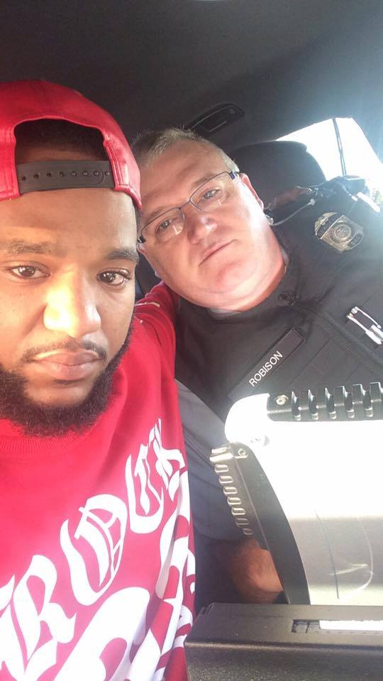
These two men don’t look very happy yet their faces give me hope. The story and picture were passed along Facebook as so many are these days. But this story was different. This man wearing the red shirt was speeding and there was a warrant out for his arrest. He should go to jail. They towed his car but the county with the warrant wouldn’t come get him. Why then are these two pictured together in this serious photo? Because this man in red began to cry as he told the other man about the death of his sister and how he was trying to get back home to be with his mom. He had begun to realize his chances of getting back home were next to none. But the man in the uniform did not arrest him then and there. Instead he began to pray over this man who was sobbing and pray for his family too. And then he offered to drive him the last 100 miles to get him home. The last line written by the man in red “This guy gave me hope.” I wonder today what makes you or gives you Hope?
We could really feel hopeless today except that stories like this prove to me that Hope has not vanished. Stories like this prove to me that Grace is still available today and Honest cries of pain and sorrow can be met with Compassion. We are not a people, in this not- always United States of America, without Hope.
This morning I read Psalm 119:49-50 “Remember your word to your servant in which you have made me hope. My comfort in my suffering is this: Your promise preserves my life.” This Psalmist had been through trying times and over and over he asks God to help him to follow the Law, the word of God, which makes him hope. He needs help him to remember and to do what is right and to receive the life that God’s promises give. But sometimes like this man in red in the picture we make mistakes – and the more we make the worse the mess gets. Then when we do the right thing – as he did trying to go help his family – his past and present wrongs stop his good deed. We all struggle with living within the law all the time. The difference is some of us just haven’t been caught! We wonder why so many men like this man in red are getting caught and losing their lives. We wonder ‘will hearts change and does mercy exist?’ We get angry and we lose our temper and say graceless things entering into the fray.
And yet, this story made me have Hope. There are men who admit they are overwhelmed with their past mistakes and their present need. There are officers of the law who can see past the warrant and the skin color and see a person in despair and then offer Consolation and Grace.
Will this man have to answer for the warrant and the speeding infraction? Yes. But in these few moments he was able to meet the immediate need of his family and mourn the loss of his sister because another person offered Grace. Should this have been allowed? I am thankful for a police officer who took the time to understand the whole picture of the situation and then decide the outcome. He didn’t seem to respond out of fear but out of Compassion. The man in red didn’t seem to respond with anger but with what appears to be Honest tears of Frustration and Grief.
I have Hope for us all that we too might learn to suspend our self-righteousness, suspend our quick judgments and instead begin to inquire and to look deeper in situations that we and others face. I have Hope that we might see that all is not as it appears. All have made mistakes but Grace is still available to be given.
I pray your day will be filled with Grace even in moments when you expect retribution or you could give retribution. I pray that the Grace so freely given by Jesus, be the Grace you offer another as a way to offer the Hope that still lives in hearts like these two men pictured above.

